


What is
Type 2 Diabetes?

Booklet

This booklet supports the videos which explain what Type 2 Diabetes is.

The information in the booklet will help you manage your Type 2 Diabetes.

The video can be found at:

Link needed here

There are also videos to show what you can expect when you go for your diabetes annual review and retinal screening appointments

List video links here??

Glossary
List of some words used in the
Type 2 Diabetes videos

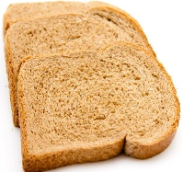  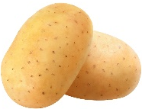  Carbohydrate | Carbohydrate-containing foods include bread, potato, pasta, rice, cereals, foods made with flour and also fruit.  The body changes carbohydrate-containing foods into glucose.
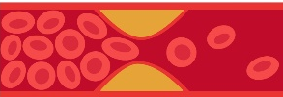  Cholesterol | Cholesterol is carried by lipoproteins in your blood.
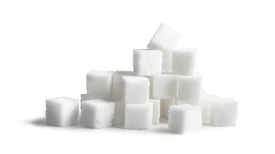  Glucose | Glucose is a type of sugar.  When we eat carbohydrate-containing foods, they are broken down releasing glucose into the blood.  The body uses glucose to make energy.
  Erectile dysfunction | When the ability to get or maintain an erection fails.
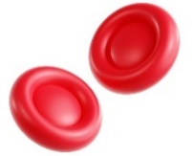  HbA1c  (Haemoglobin A1c) | HbA1c is a measure of your overall blood glucose level over the past 3 months.  HbA1c is measured in mmol/mol.
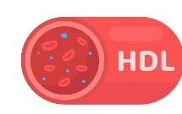  HDL | HDL (High Density Lipoprotein) is sometimes known as “good cholesterol” as HDL carries cholesterol to the liver for disposal.
Hypoglycaemia  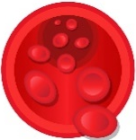 | Hypoglycaemia is where the level of sugar in the blood drops below 4mmol/L.  If you are taking certain glucose-lowering medications, you may be at risk of hypoglycaemia.
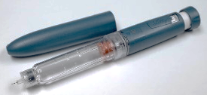  Insulin | Insulin acts as a chemical key which allows cells to convert the glucose into energy.

Glossary
List of some words used in the
Type 2 Diabetes videos

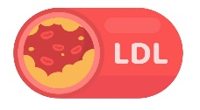  LDL | LDL (Low Density Lipoprotein) is sometimes known as “bad cholesterol”  LDL can cause formation of fatty areas in the blood vessel walls and cause narrowing of the blood vessel.
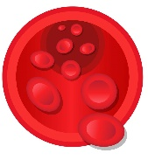  Lipoprotein | Lipoproteins carry cholesterol in the blood.
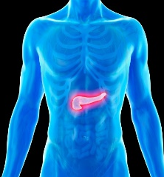  Pancreas | The pancreas is an organ in your body.  The pancreas makes insulin.
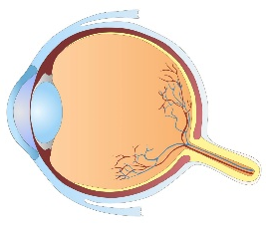  Retina | The retina is a layer of tissue on the inside of the back of the eyeball.  The retina sends pictures of what you see to your brain.
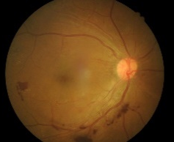  Retinopathy | Retinopathy is damage to the small blood vessels in the retina at the back of the eye.
Saturated  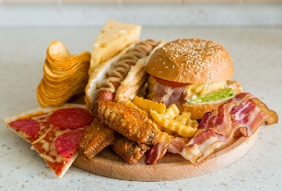  Fat | Saturated fats are usually solid at room temperature.  A diet high in saturated fat is linked to “bad cholesterol”.
Unsaturated Fat  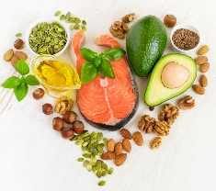 | Unsaturated fats are usually liquid at room temperature.  They can help to maintain healthy cholesterol levels.

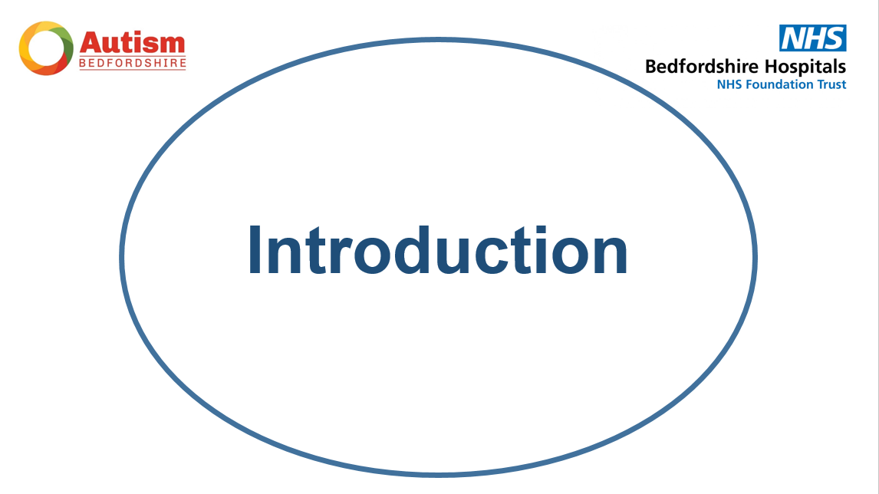

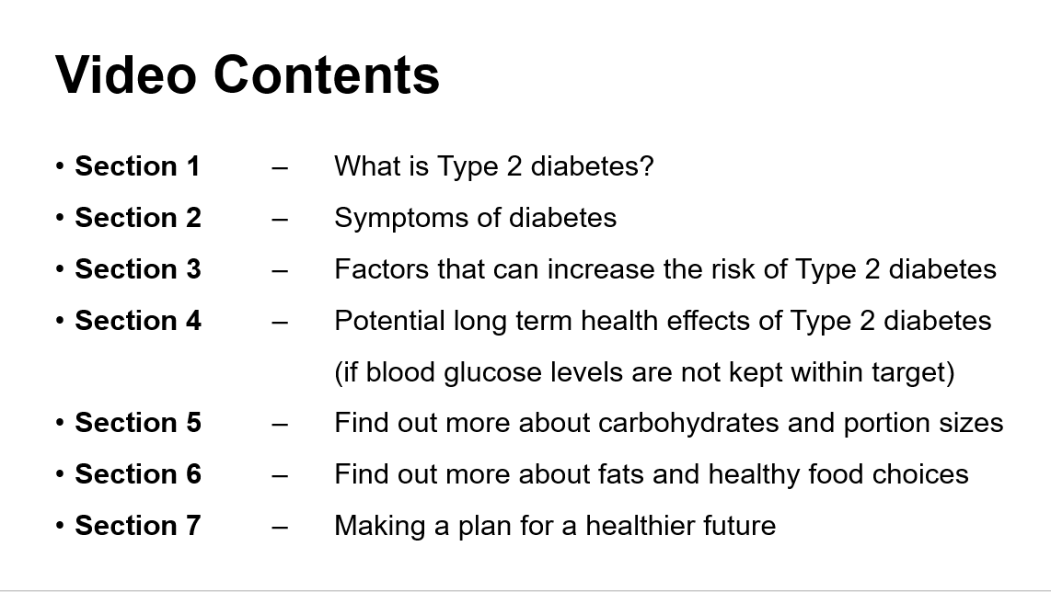
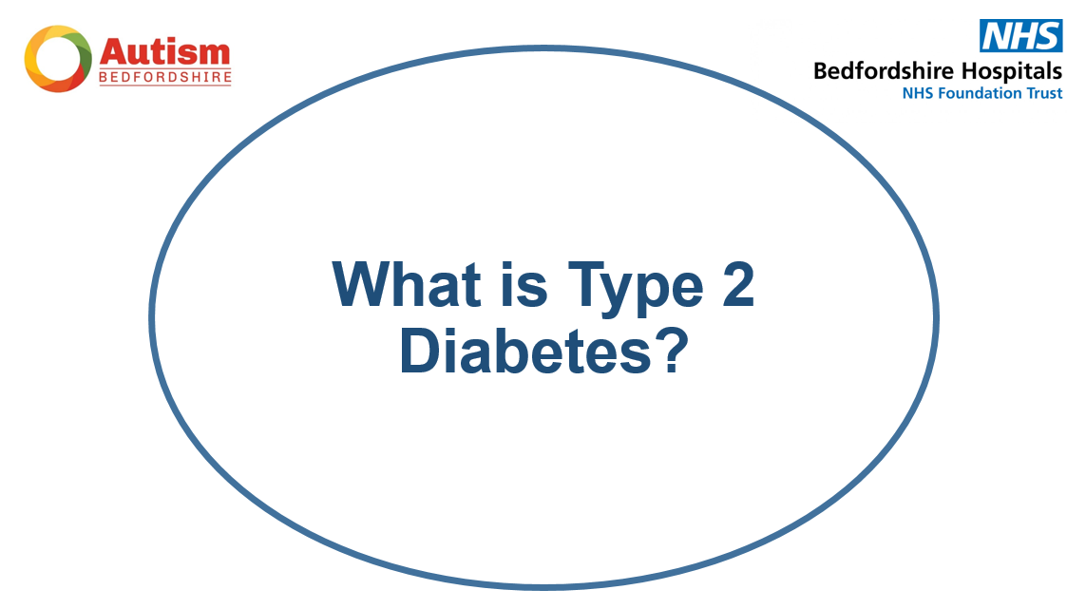
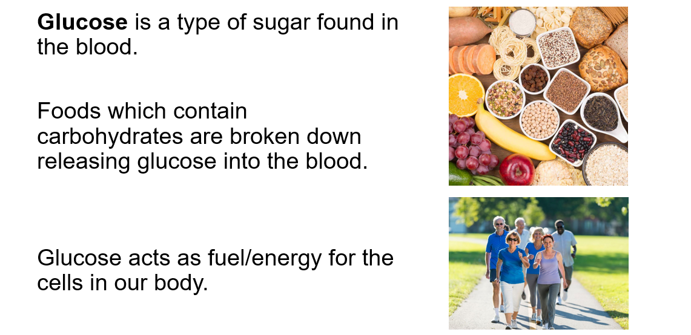
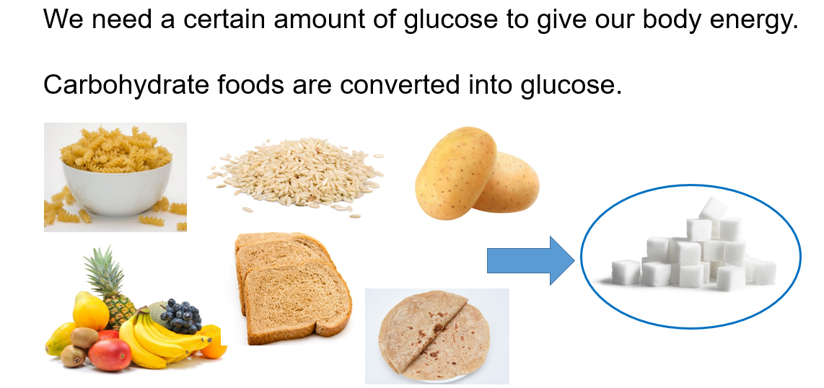

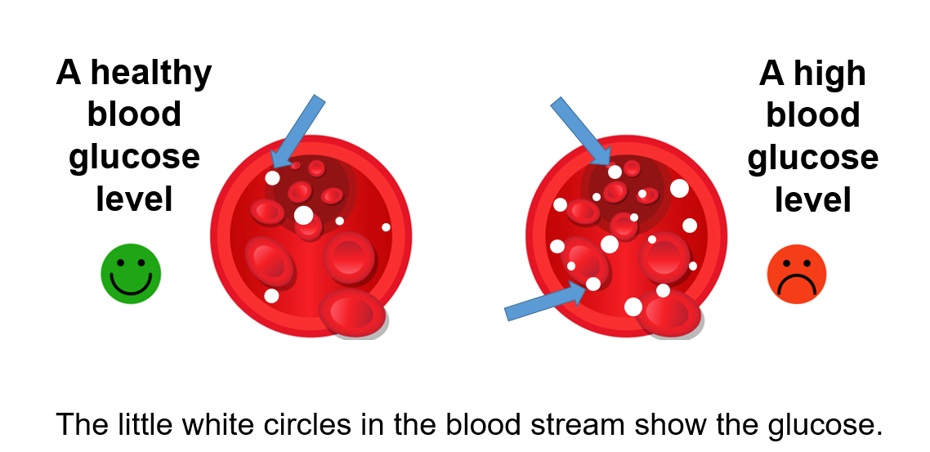

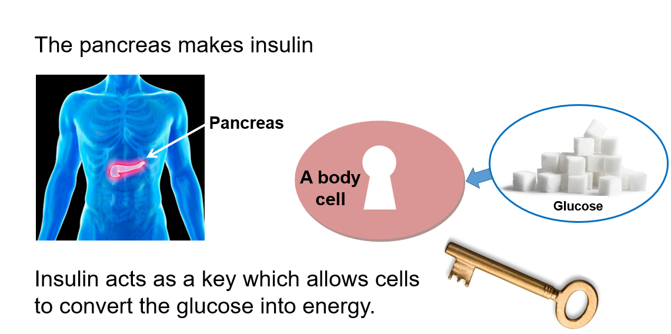

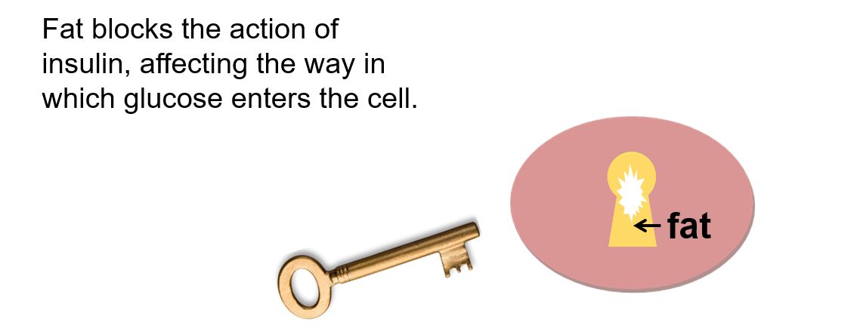

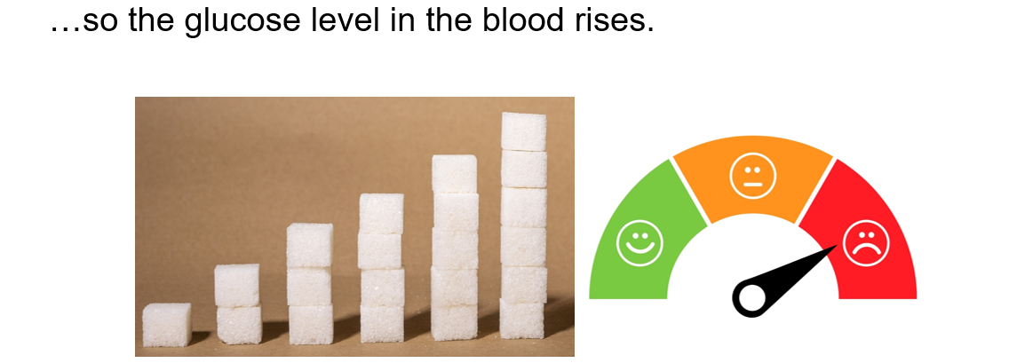

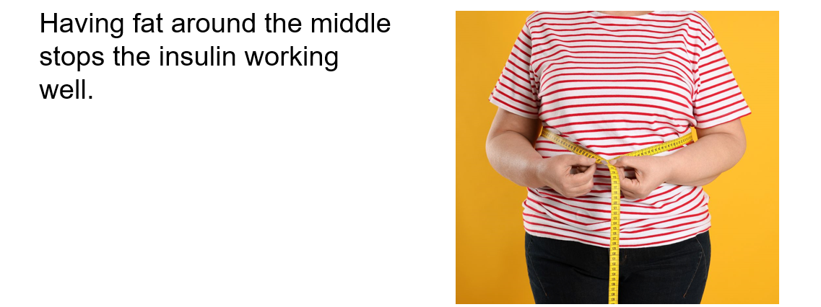

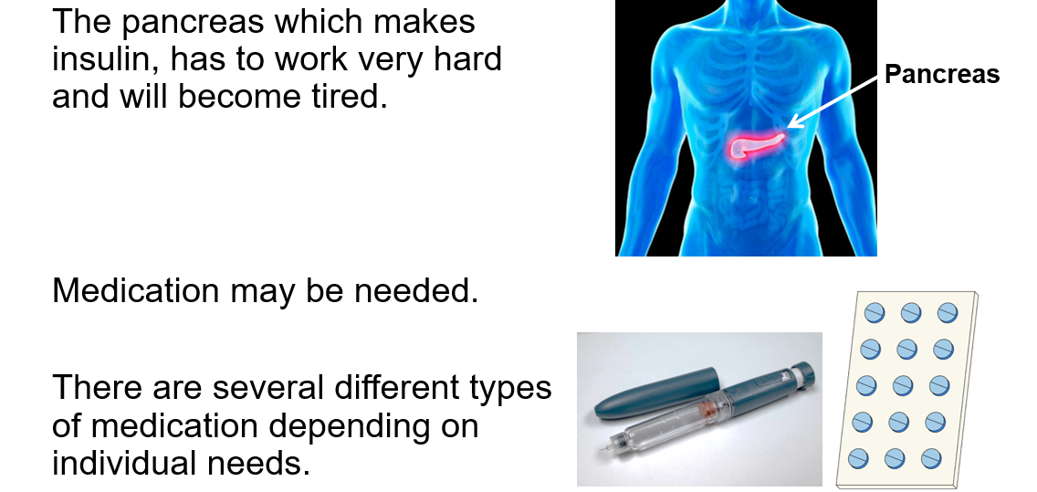

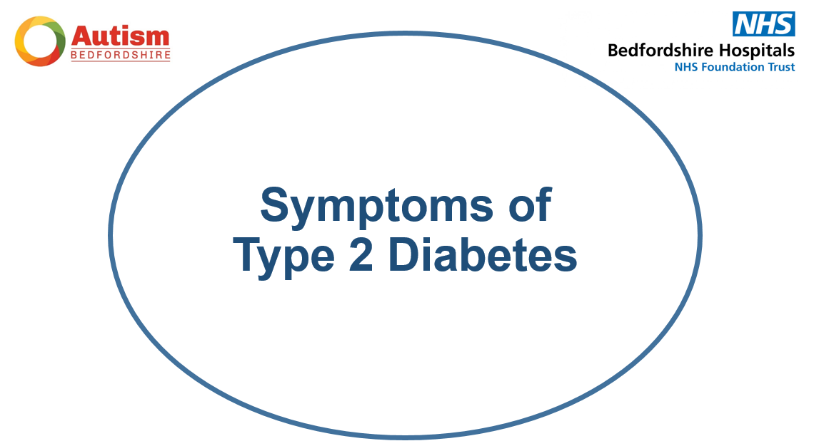

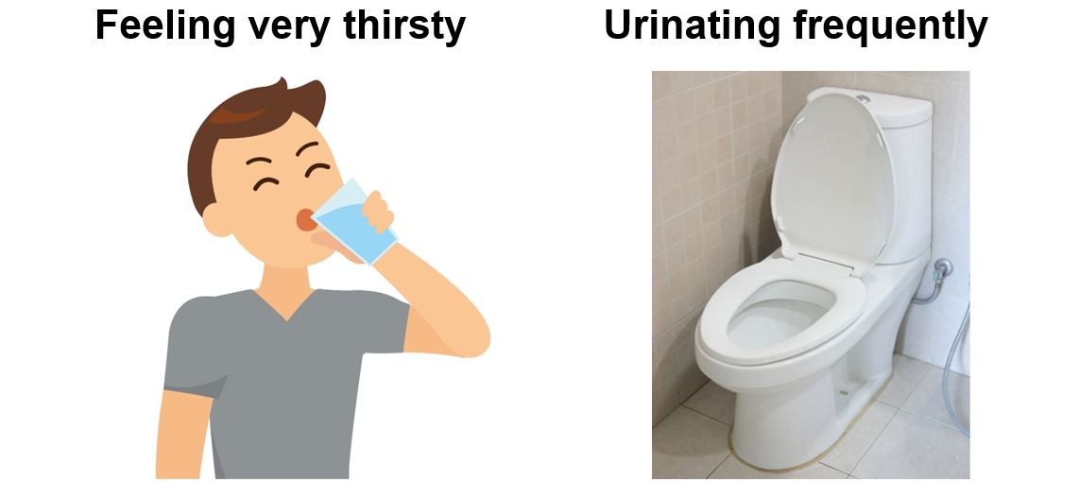

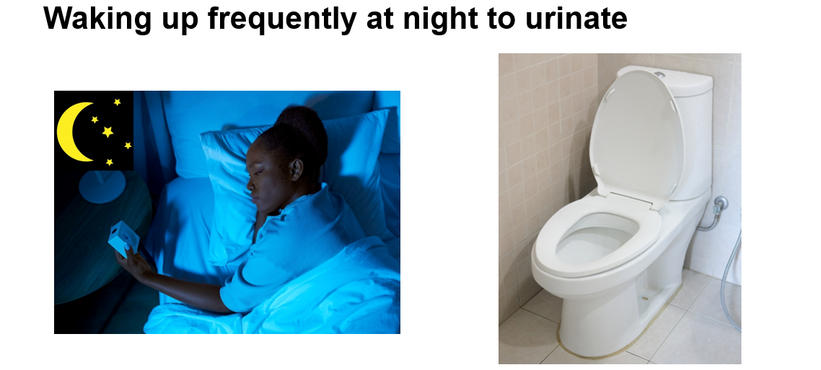

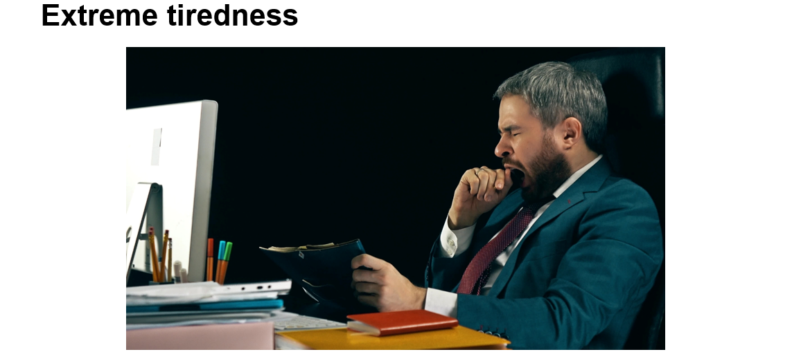

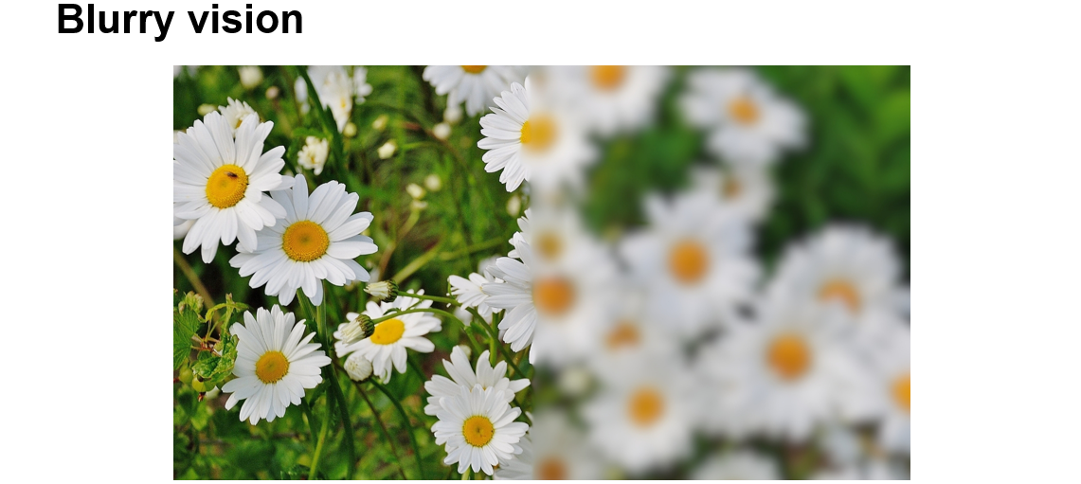

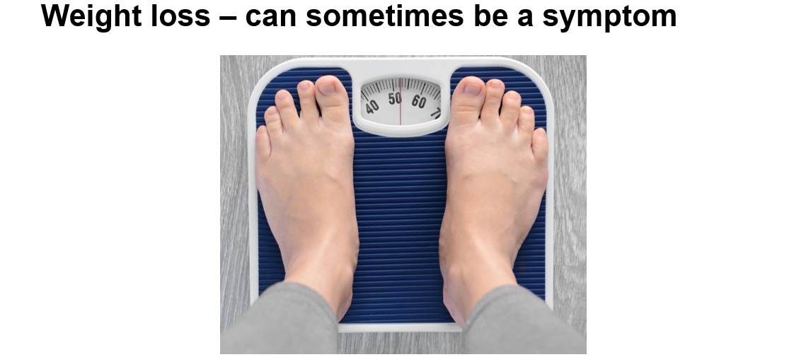

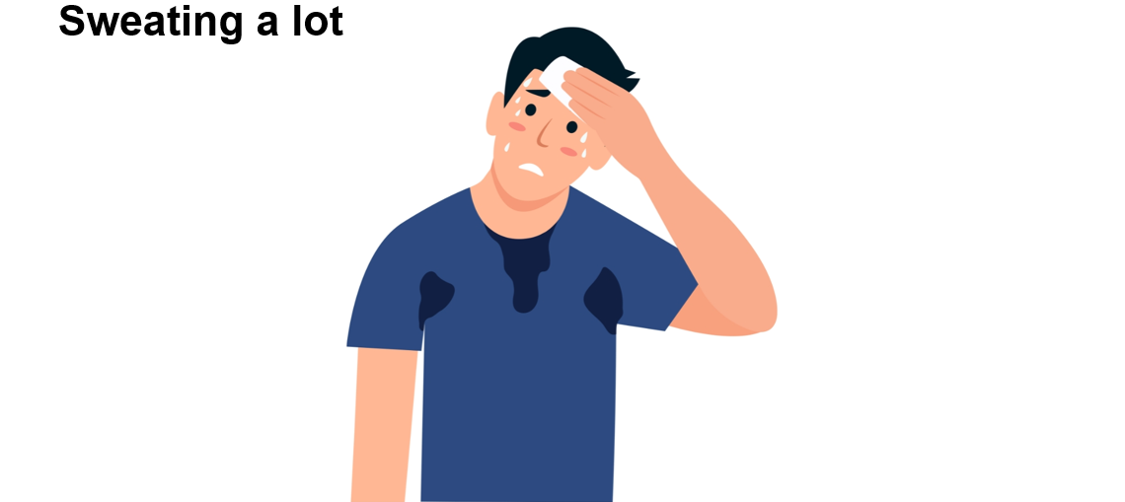

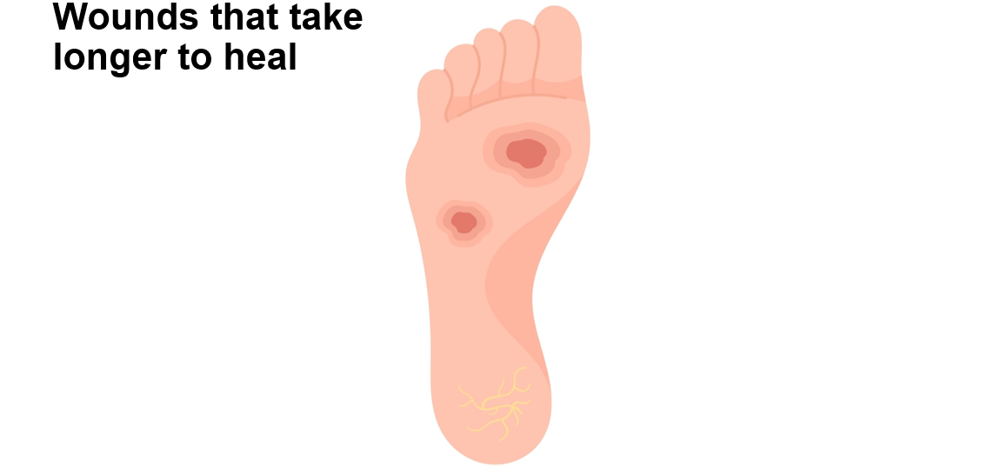

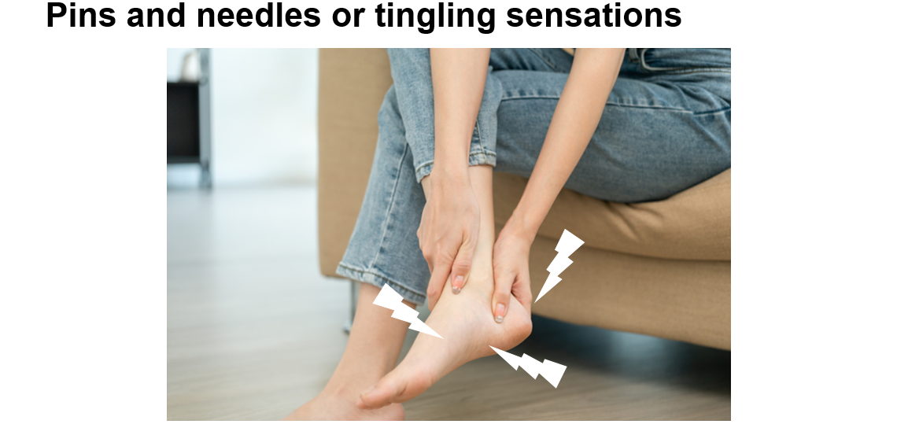

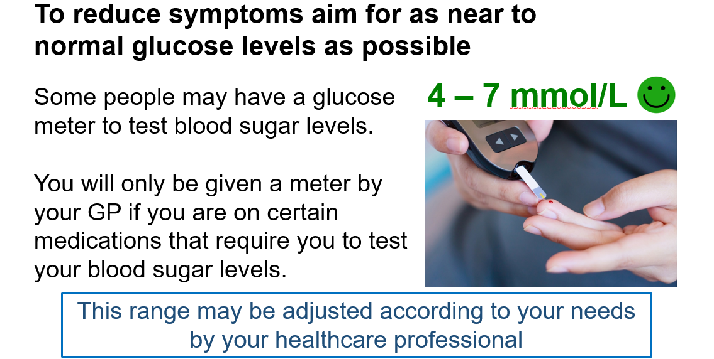

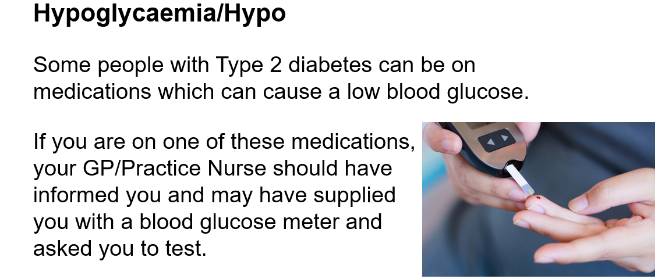

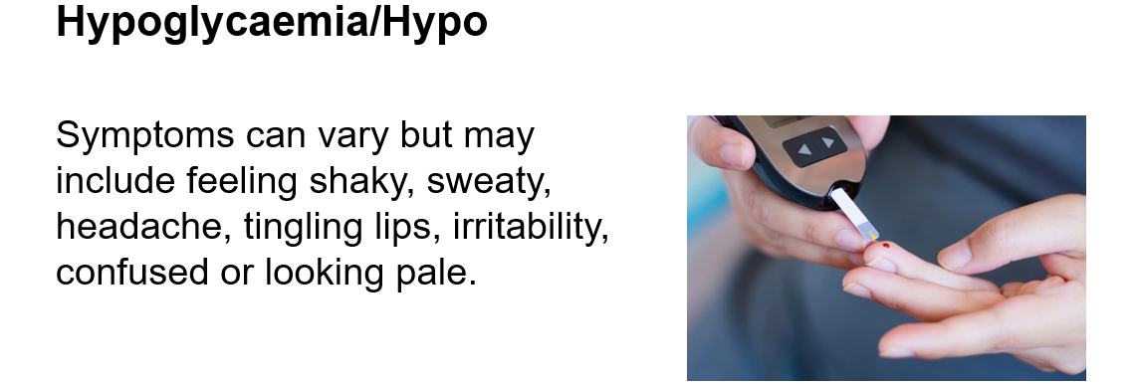

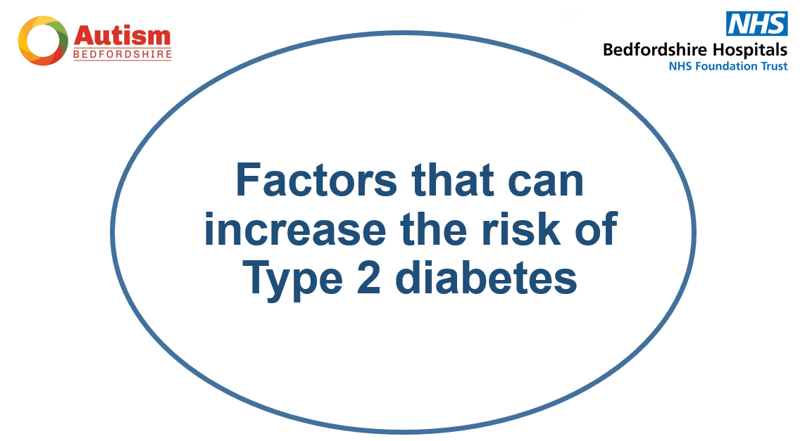

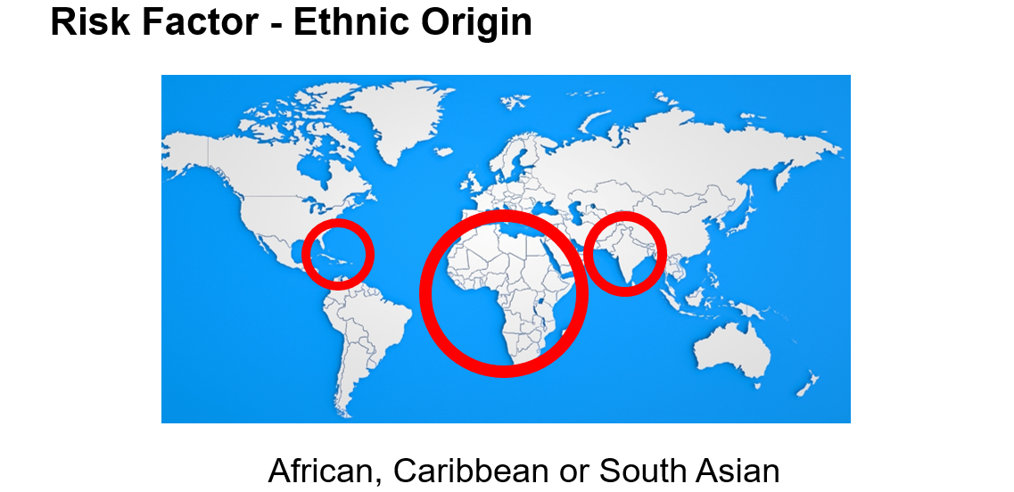

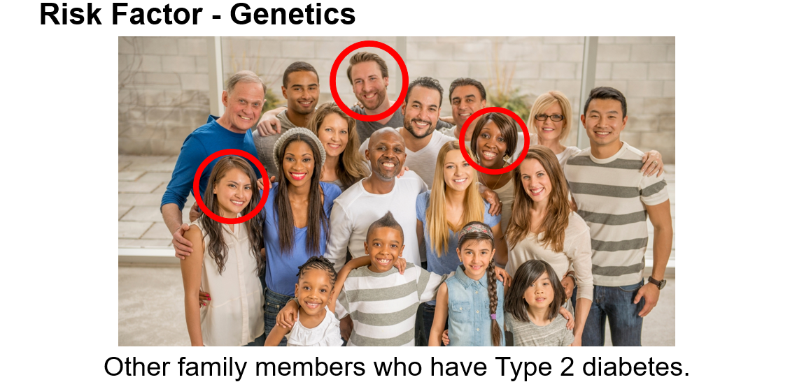

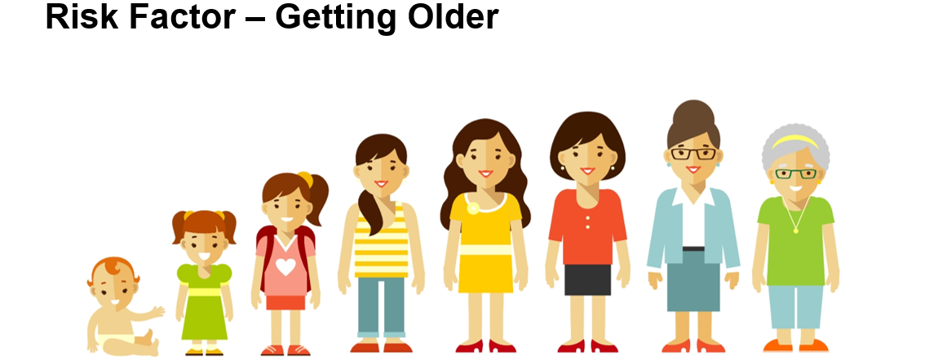

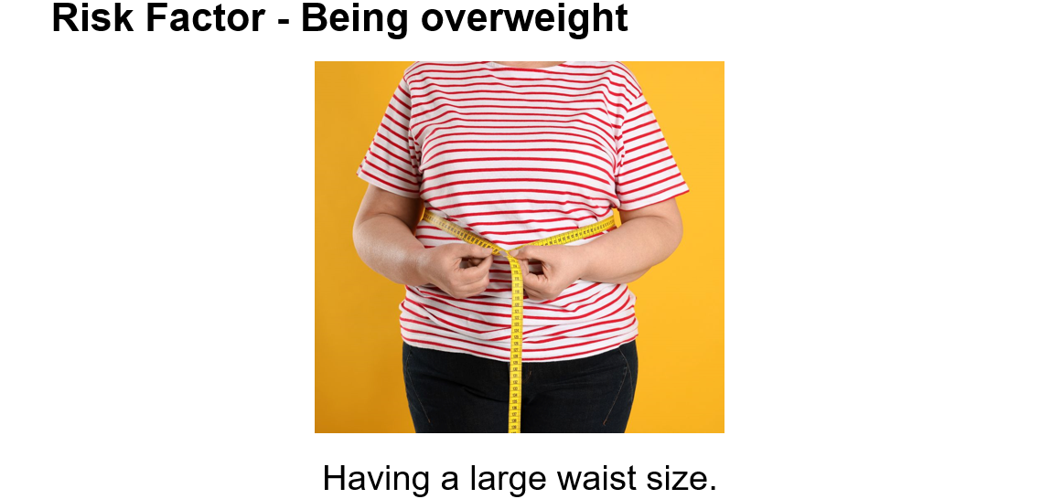

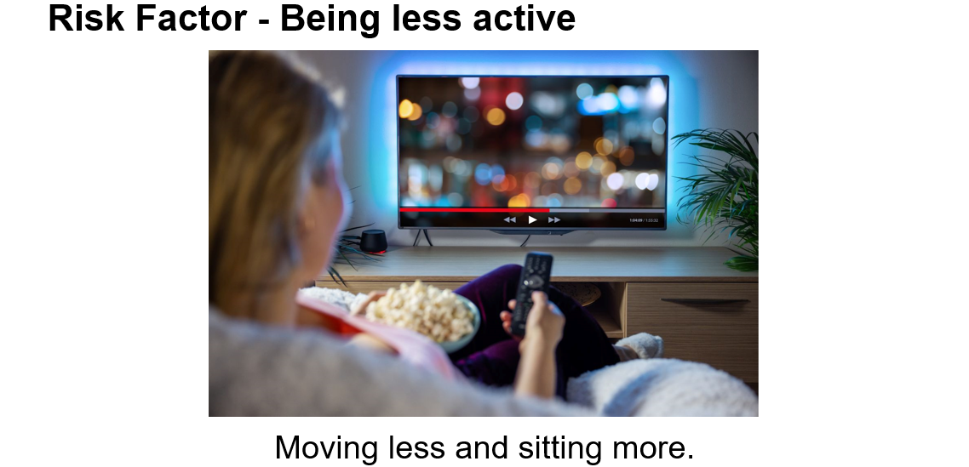

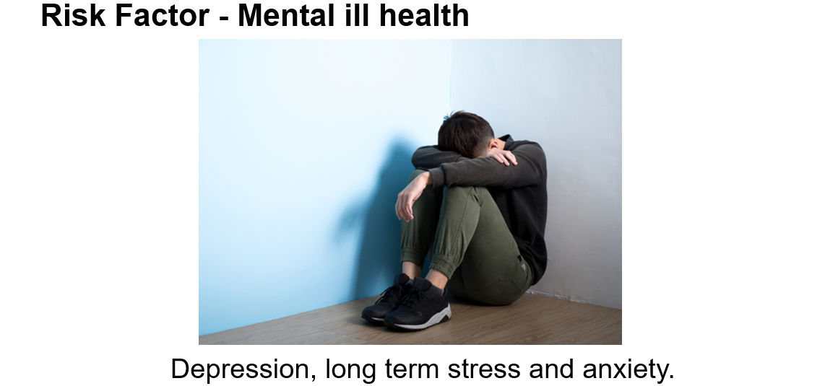

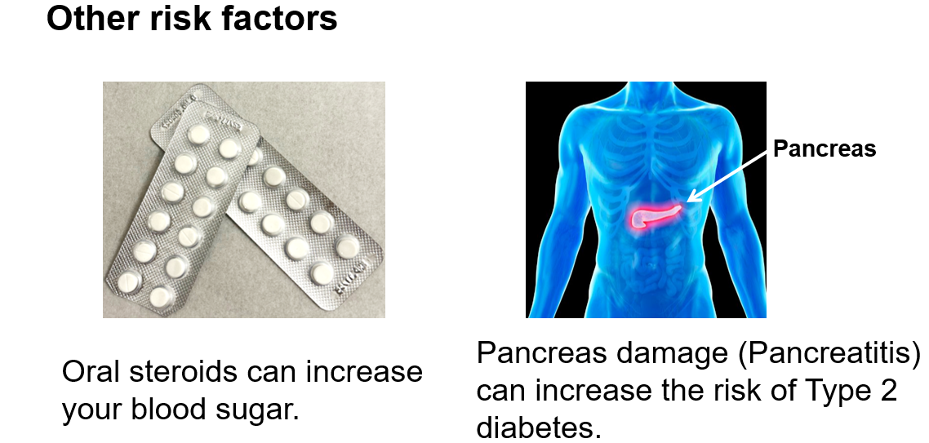

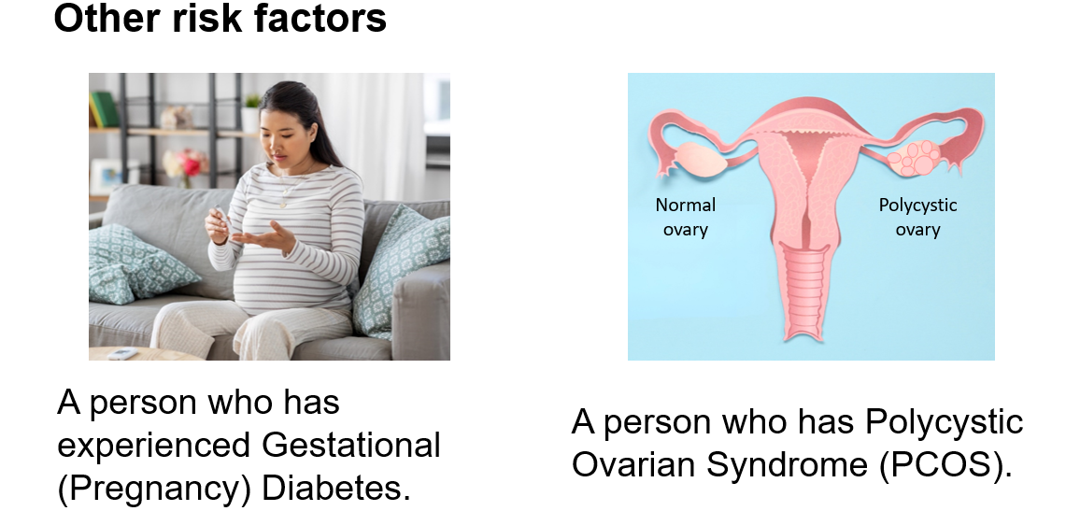

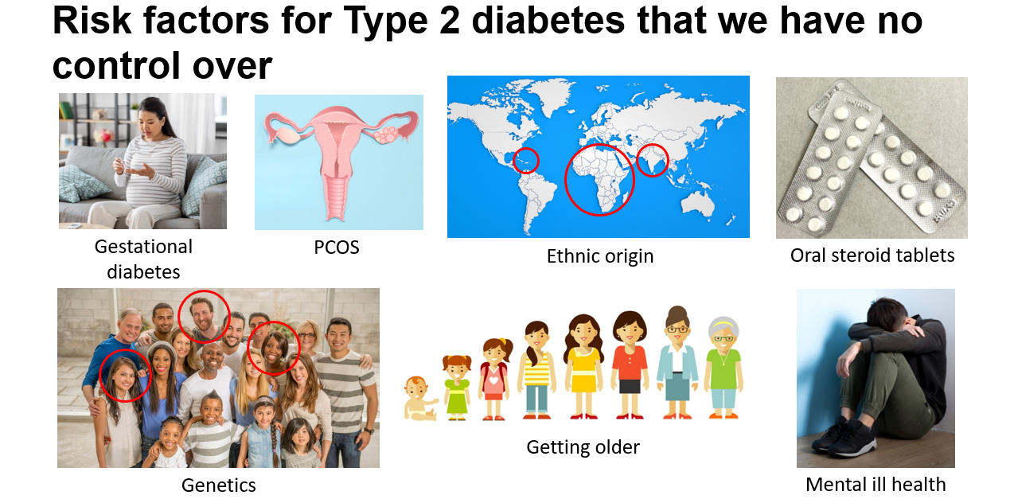

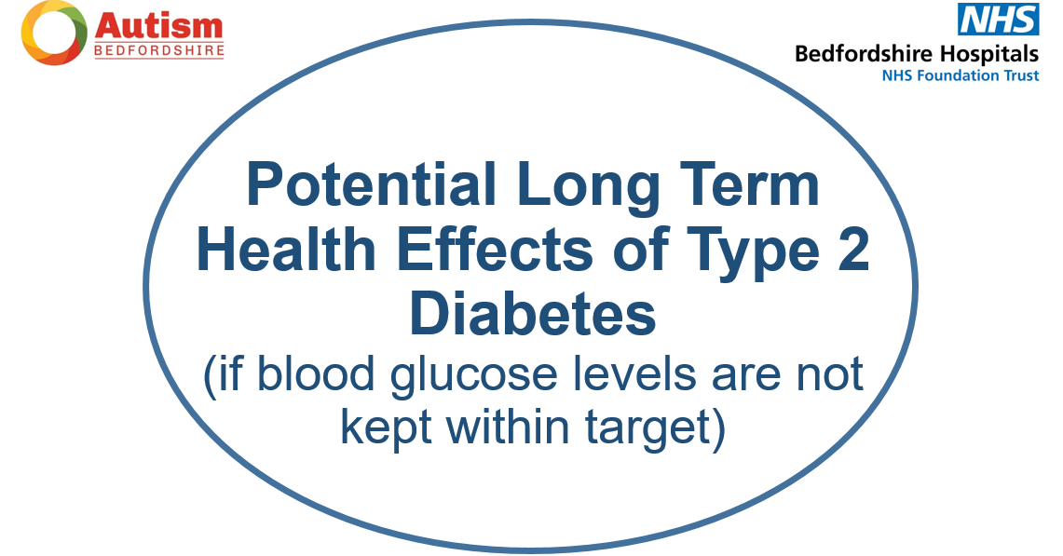

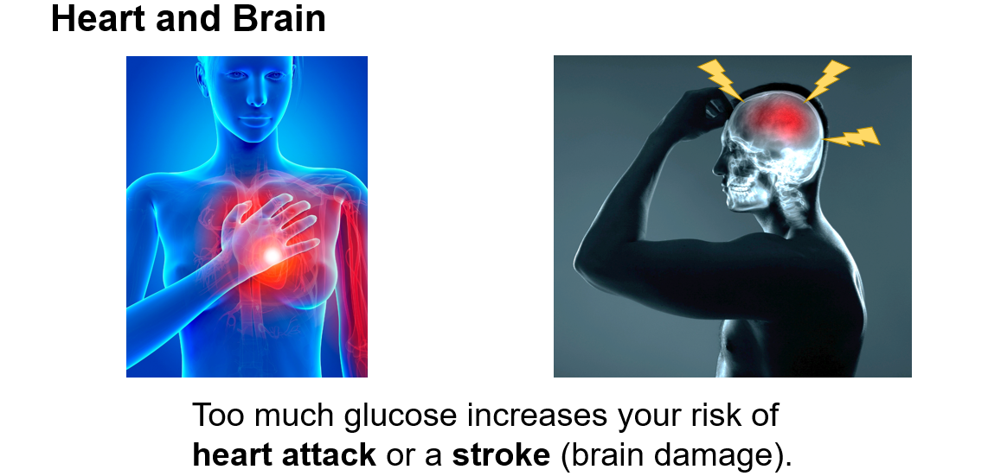
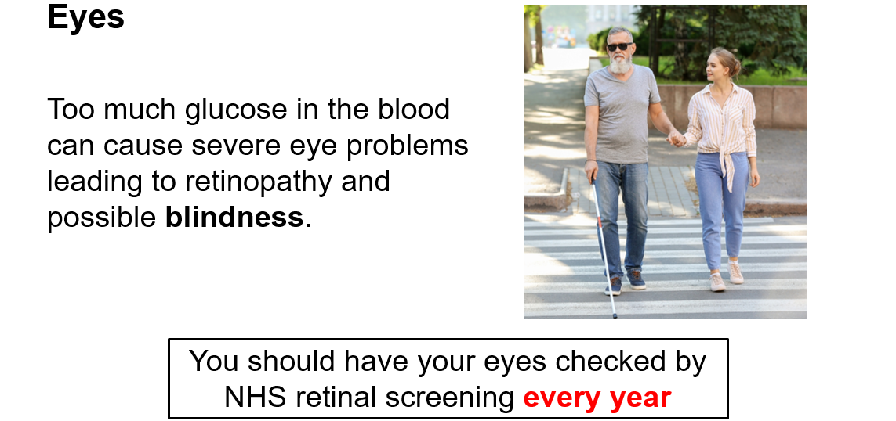
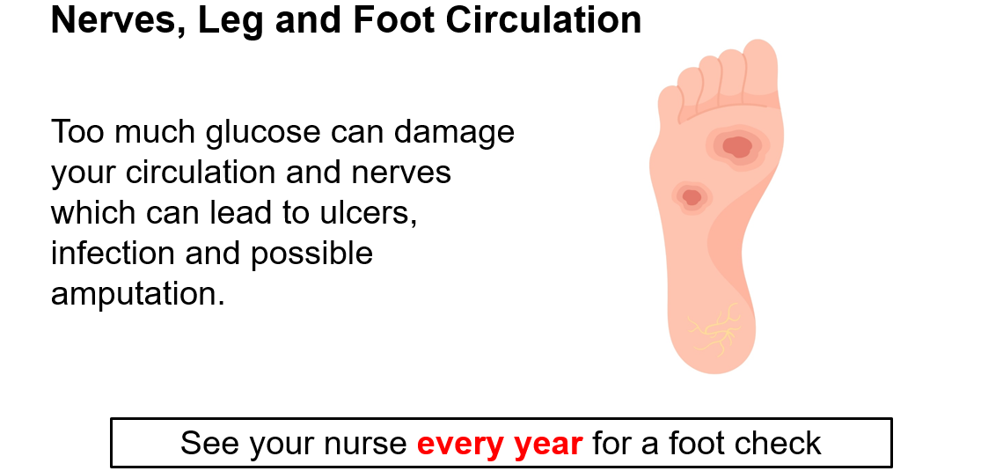

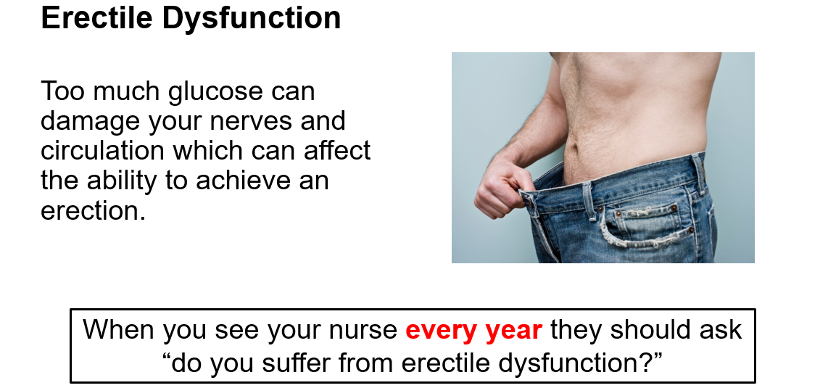
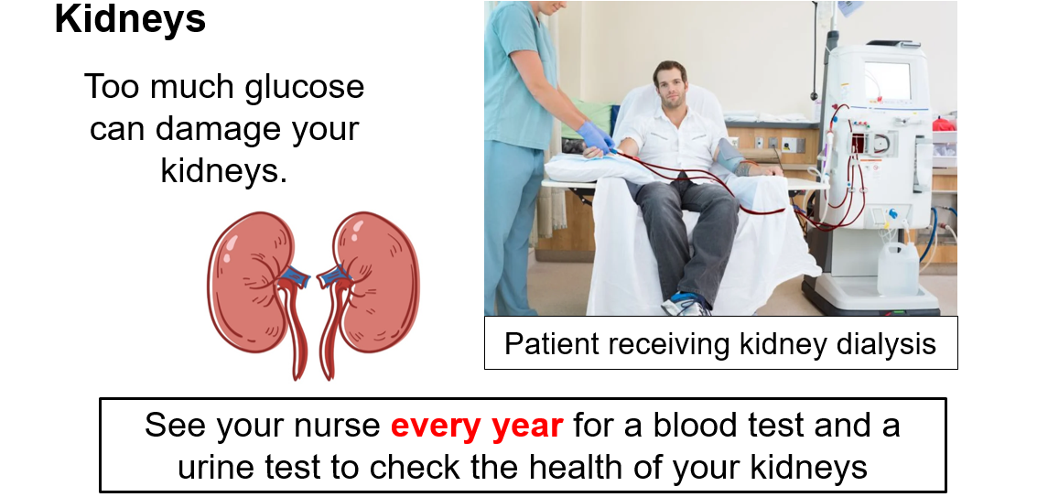
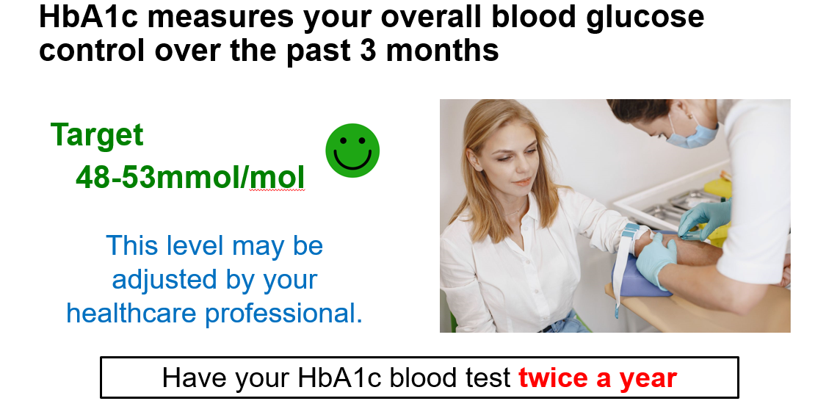

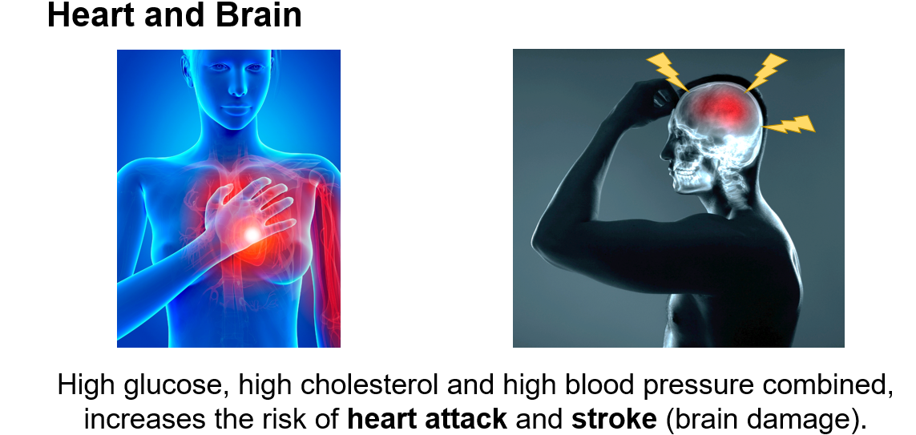
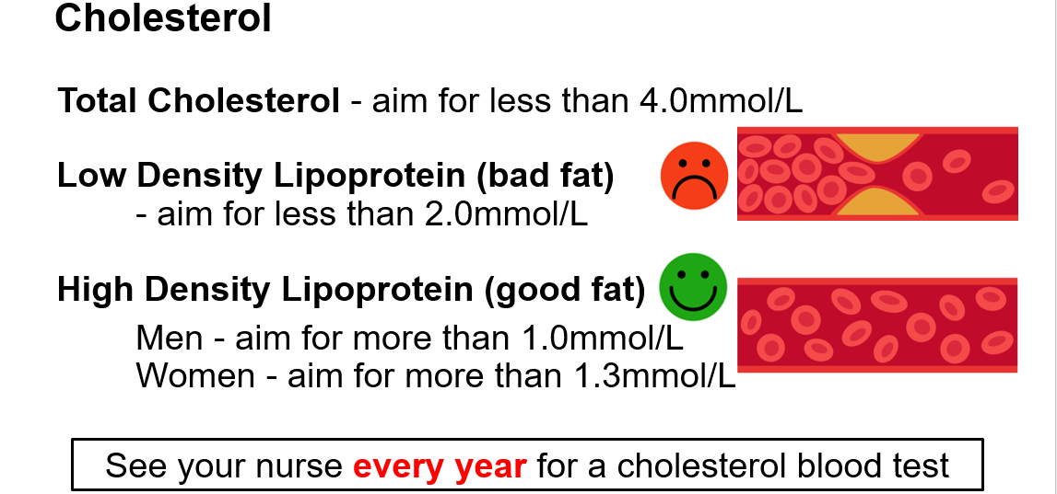
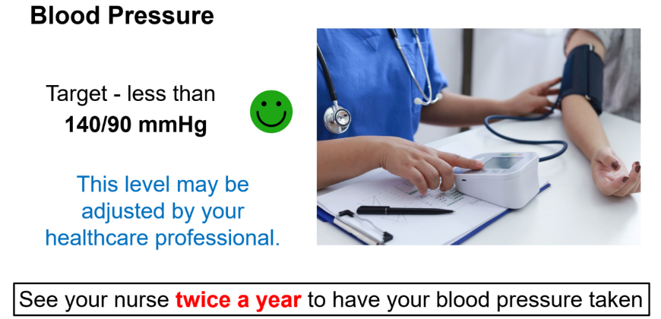

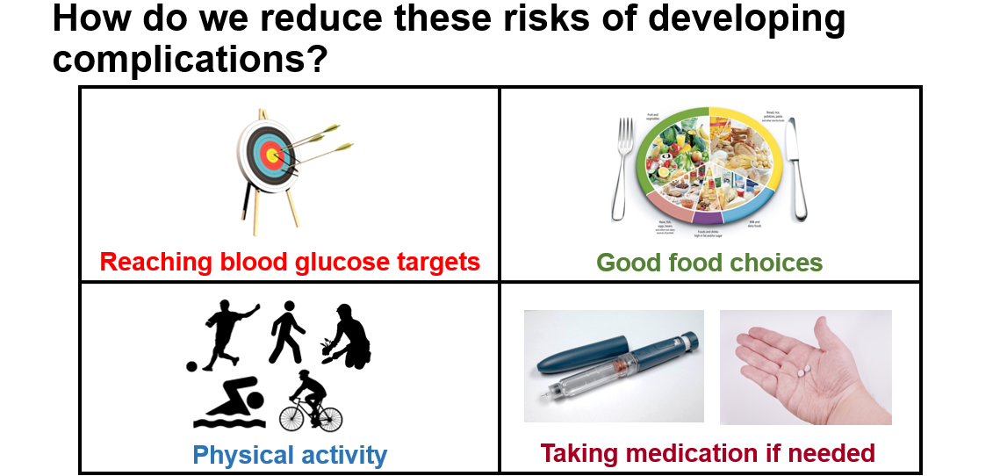
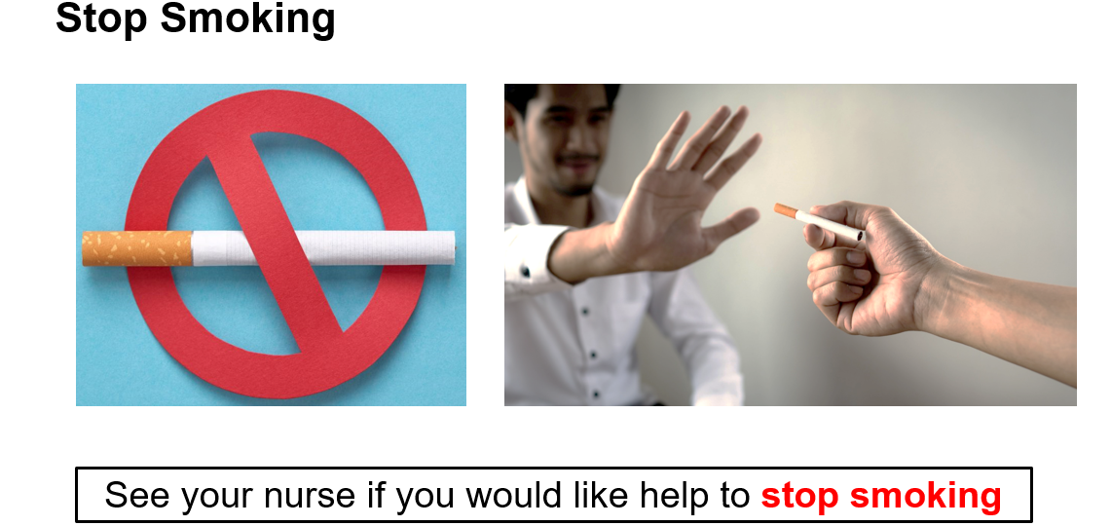
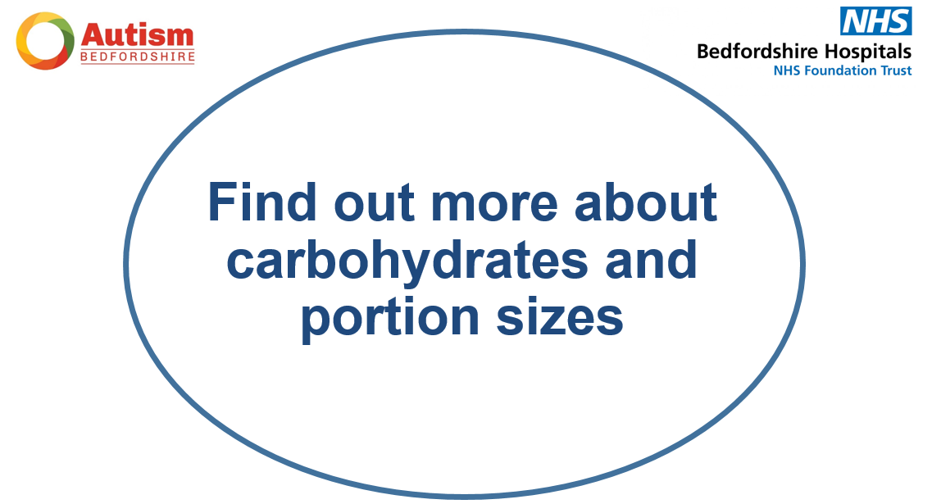

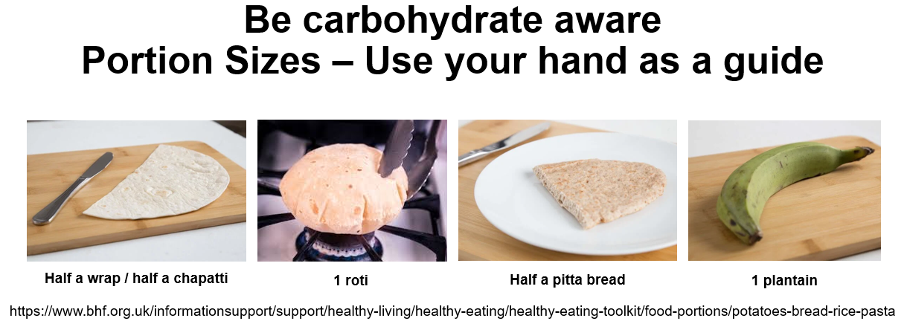
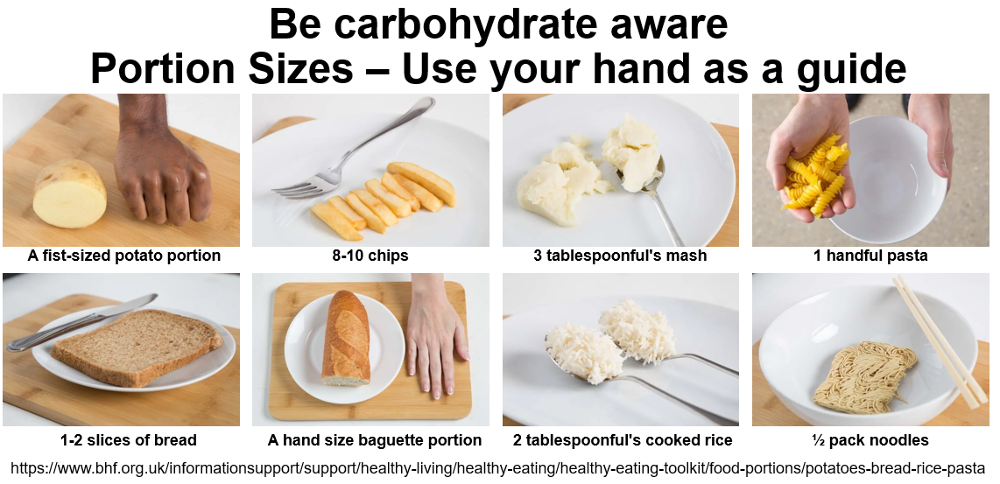
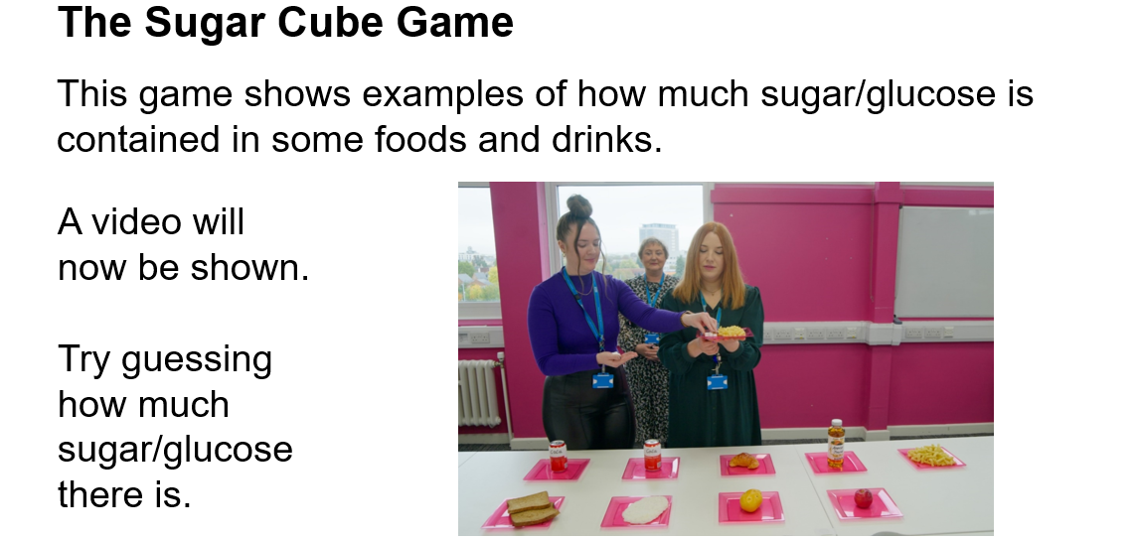

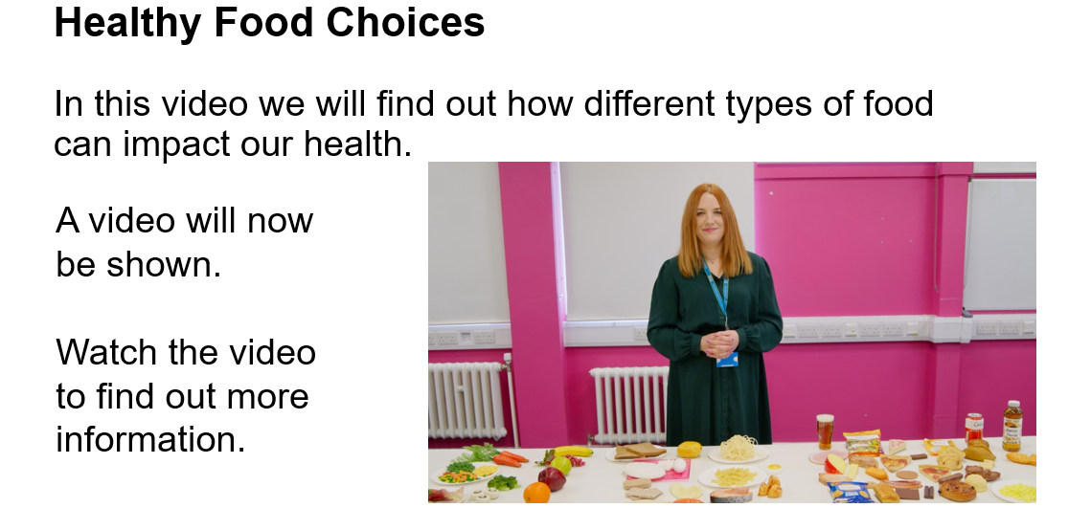
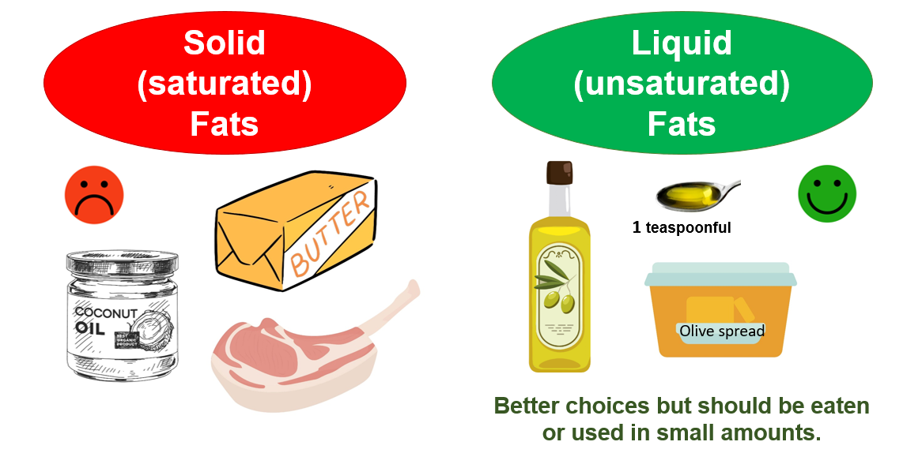
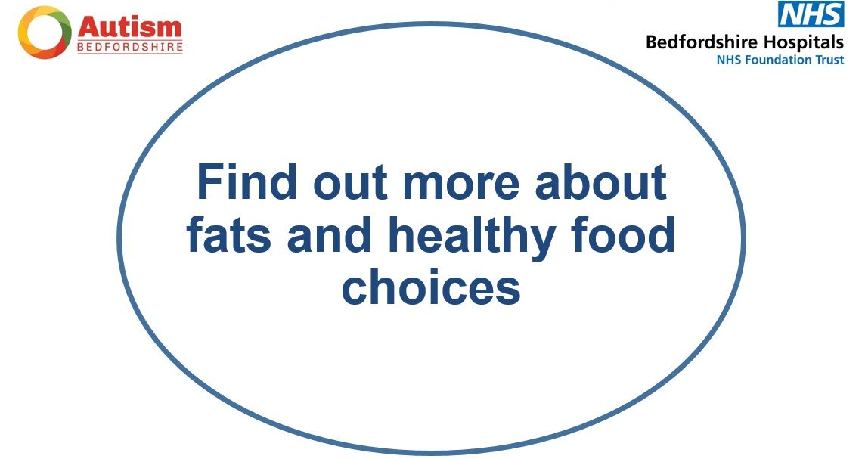
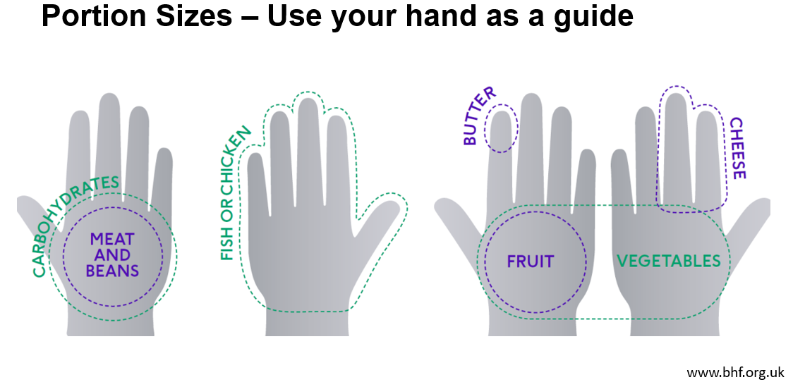

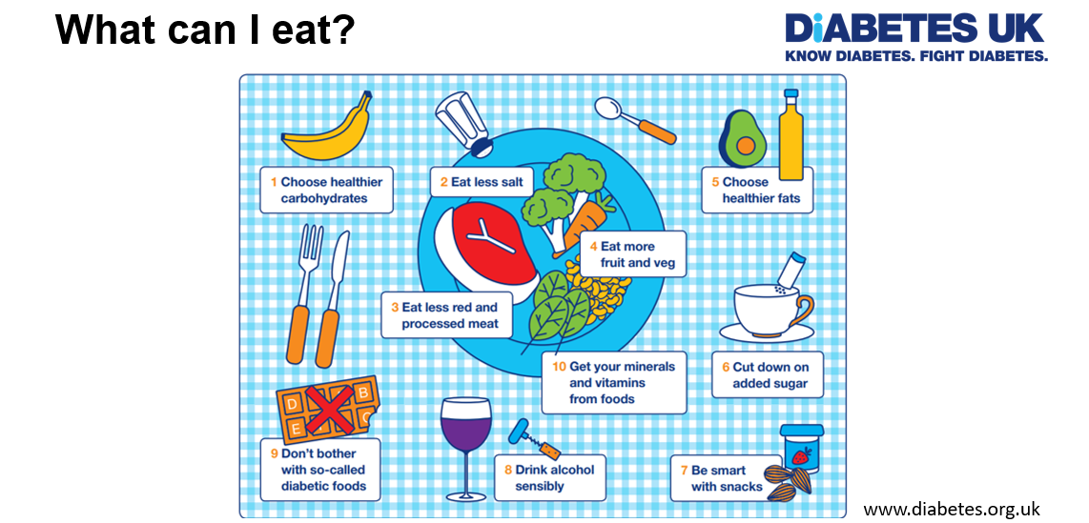
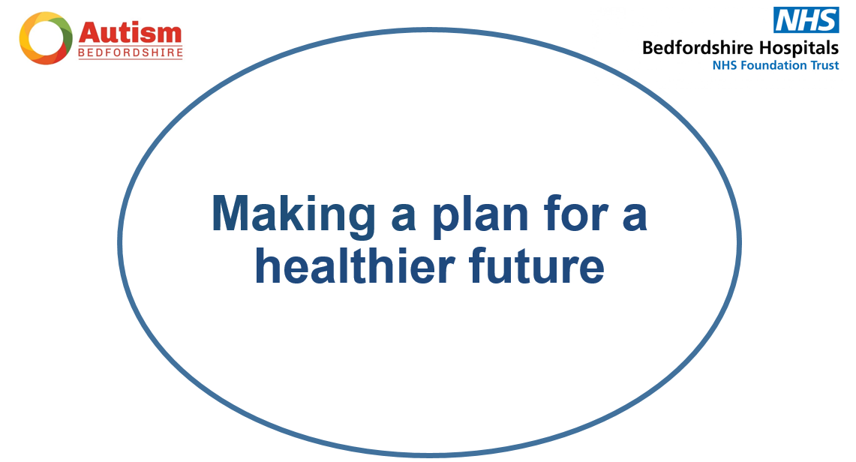

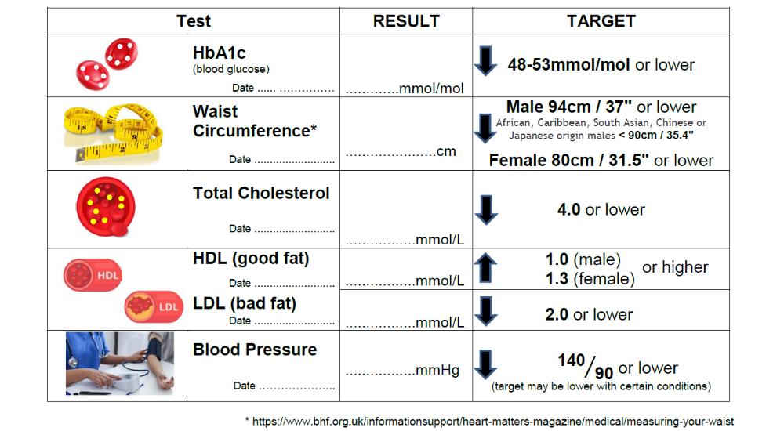
Full size biomedical data sheet on page 25

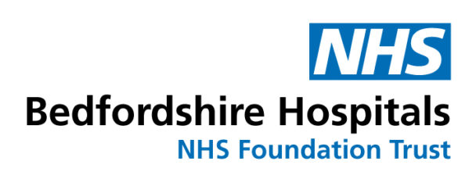
23
* https://www.bhf.org.uk/informationsupport/heart-matters-magazine/medical/measuring-your-waist

My Biomedical Data
Test |  | RESULT | TARGET
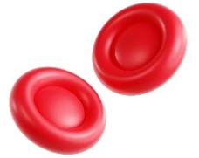 | HbA1c  (blood glucose)  Date ...... …………… | .............mmol/mol | 48-53mmol/mol or lower
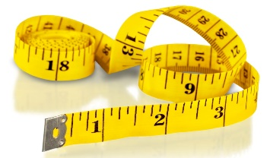 | Waist Circumference*  Date .......................... | ......................cm | Male 94cm / 37" or lower  African, Caribbean, South Asian, Chinese or Japanese origin males < 90cm / 35.4"  Female 80cm / 31.5" or lower
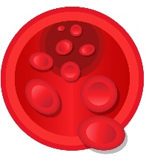 | Total Cholesterol  Date .......................... | .................mmol/L | 4.0 or lower
 | HDL (good fat)  Date .......................... | .................mmol/L | 1.0 (male)  or higher  1.3 (female)
 | LDL (bad fat)  Date .......................... | .................mmol/L | 2.0 or lower
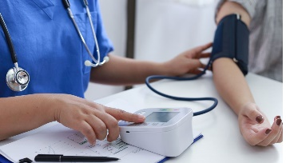 | Blood Pressure  Date ………………... | .................mmHg | ${\text{140}}/{\text{90}}$ or lower  (target may be lower with certain conditions)

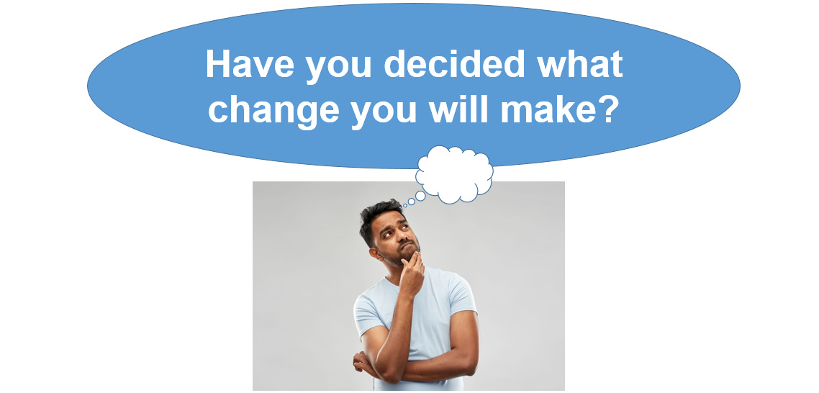
You might like to fill in the change plan on p27

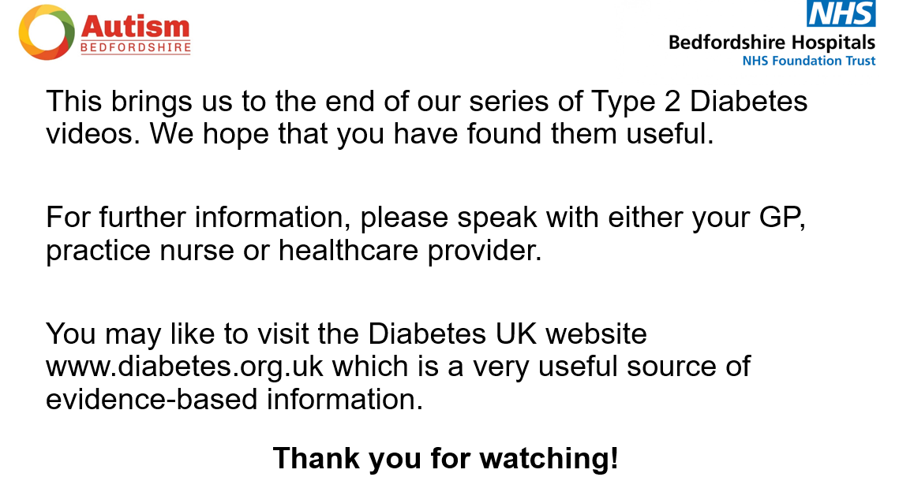

My Diabetes Change Plan

What am I going to do to improve my health?
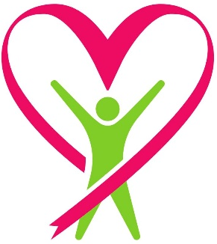
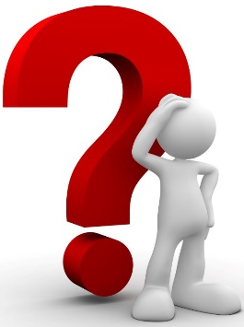
How exactly am I going to do this?

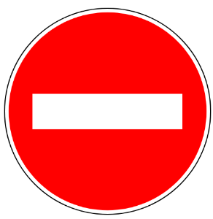
What might stop me?

What will I do to overcome these barriers?
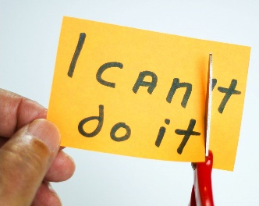


When will I review my plan?

