List of some words used in the
Type 2 Diabetes videos

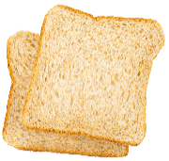  Carbohydrate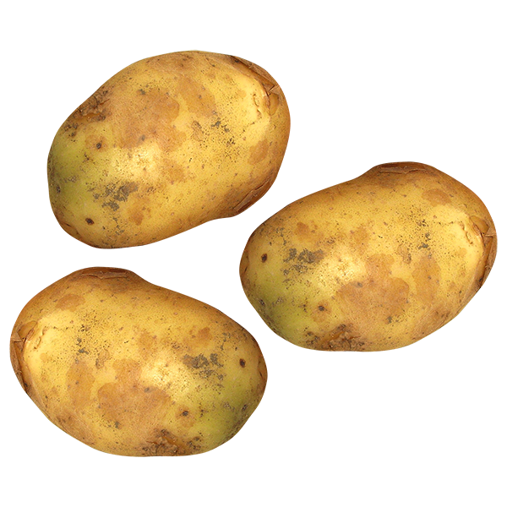 | Carbohydrate-containing foods include bread, potato, pasta, rice, cereals, foods made with flour and also fruit.  The body changes carbohydrate-containing foods into glucose.
Cholesterol  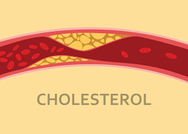 | Cholesterol is carried by lipoproteins in your blood.
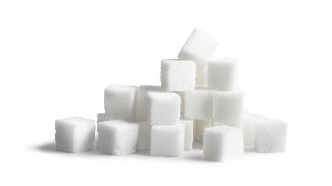  Glucose | Glucose is a type of sugar.  When we eat carbohydrate-containing foods, they are broken down releasing glucose into the blood.  The body uses glucose to make energy.
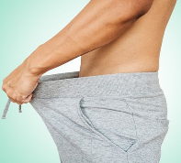  Erectile dysfunction | When the ability to get or maintain an erection fails.
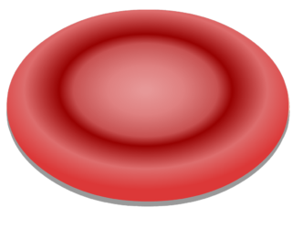  HbA1c  (Haemoglobin A1c) | HbA1c is a measure of your overall blood glucose level over the past 3 months.  HbA1c is measured in mmol/mol.
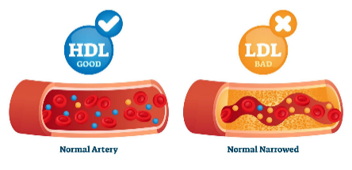  HDL | HDL (High Density Lipoprotein) is sometimes known as “good cholesterol” as HDL carries cholesterol to the liver for disposal.
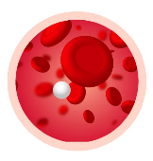  Hypoglycaemia | Hypoglycaemia is where the level of sugar in the blood drops below 4mmol/L.  If you are taking certain glucose-lowering medications, you may be at risk of hypoglycaemia.
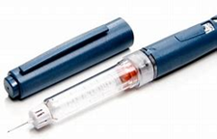  Insulin | Insulin acts as a chemical key which allows cells to convert the glucose into energy.

LDL  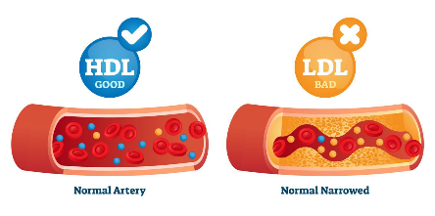 | LDL (Low Density Lipoprotein) is sometimes known as “bad cholesterol”  LDL can cause formation of fatty areas in the blood vessel walls and cause narrowing of the blood vessel.
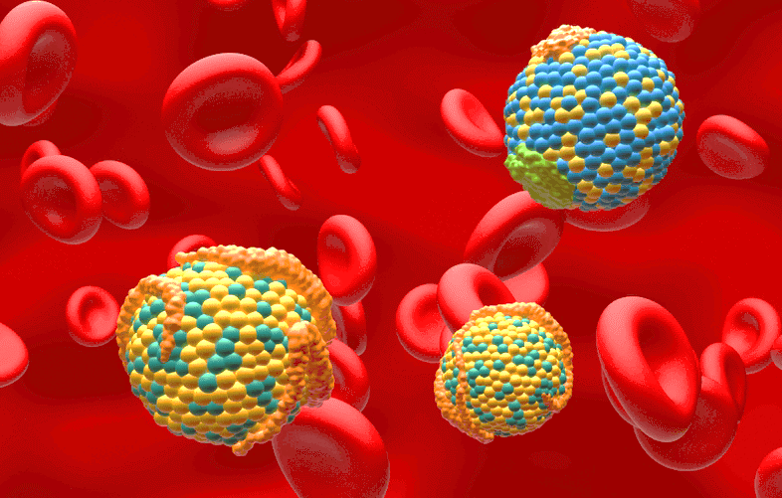  Lipoprotein | Lipoproteins carry cholesterol in the blood.
Pancreas  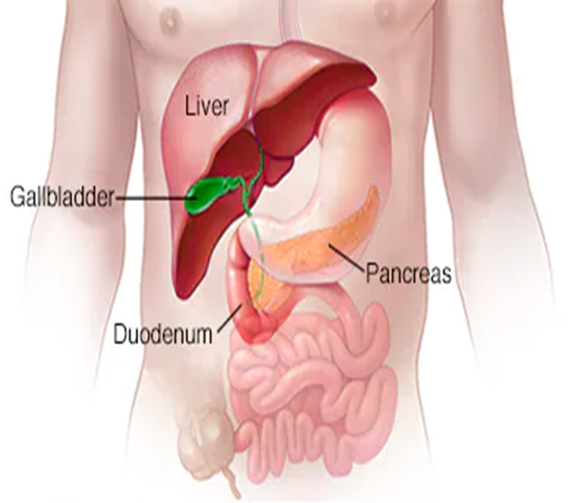  Pancreas | The pancreas is an organ in your body.  The pancreas makes insulin.
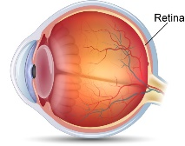  Retina | The retina is a layer of tissue on the inside of the back of the eyeball.  The retina sends pictures of what you see to your brain.
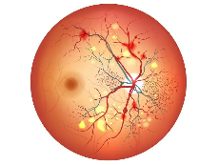  Retinopathy | Retinopathy is damage to the small blood vessels in the retina at the back of the eye.
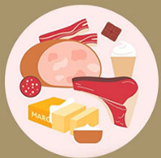  Saturated  Fat | Saturated fats are usually solid at room temperature.  A diet high in saturated fat is linked to “bad cholesterol”.
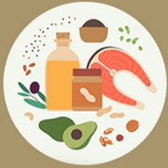  Unsaturated Fat | Unsaturated fats are usually liquid at room temperature.  They can help to maintain healthy cholesterol levels.

