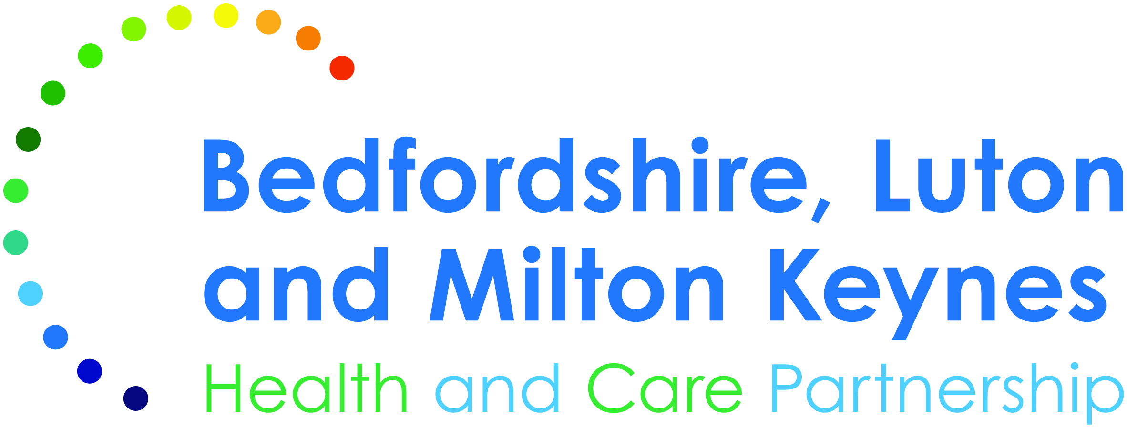
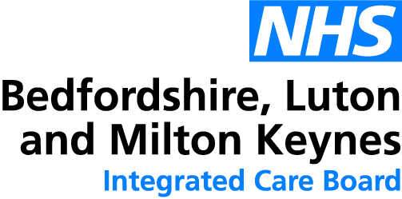

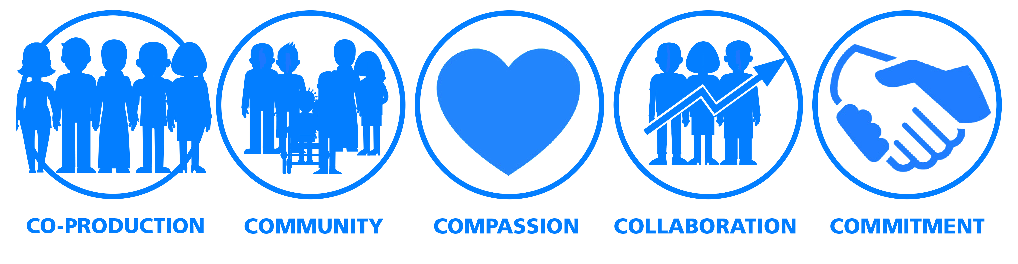
Independent Non-Executive Members
for proposed Bedfordshire, Luton, and Milton Keynes Integrated Care Board

Applicant information pack for:

1 x Non-Executive Member

2 x Associate Non-Executive Members

Contents

- The Integrated Care System and the role of the Integrated Care Board
- The Opportunity: The roles of the Non-Executive Member and Associate Non-Executive Members
- About us in BLMK
- BLMK ICS Leadership and ICS Establishment
- The role, job description and person specification
- Eligibility
- Terms of appointment
- More information
- Making an application

We are committed to, and promote actively, equality of opportunity for all staff. Applications from individuals from all areas of the community who meet the specific criteria are encouraged, therefore, regardless of age, disability, sex, gender reassignment, sexual orientation, pregnancy and maternity, race, religion or belief and marriage/civil partnerships.

We would welcome applications particularly from candidates with protected characteristics as it is important as a Board that we reflect the people we serve.
- The Integrated Care System and the role of the Integrated Care Board

Integrated care systems (ICSs) are partnerships of health and care organisations, local government, and the voluntary sector. They exist primarily to improve the population’s long-term health and wellbeing and to tackle longstanding health inequalities. By integrating health and care services, ICSs will enhance service productivity and support broader social and economic development, e.g. employment and by working with local suppliers.

ICSs will take on statutory form from Friday 1 July 2022 and will comprise an Integrated Care Board (ICB) and an Integrated Care Partnership (ICP). The ICP will set the strategy for the whole system. The ICB is the statutory body that will determine how NHS funds will be used to deliver that strategy, whilst also commissioning and regulating the quality, safety, and outcomes of services.

Our ICS spans Bedfordshire, Luton and Milton Keynes and includes at least 40 partners as shown below. There is also a wider stakeholder membership, such as the Voluntary and Community Sector, Healthwatch and Primary Care Networks.

Find out more about us in section 3.

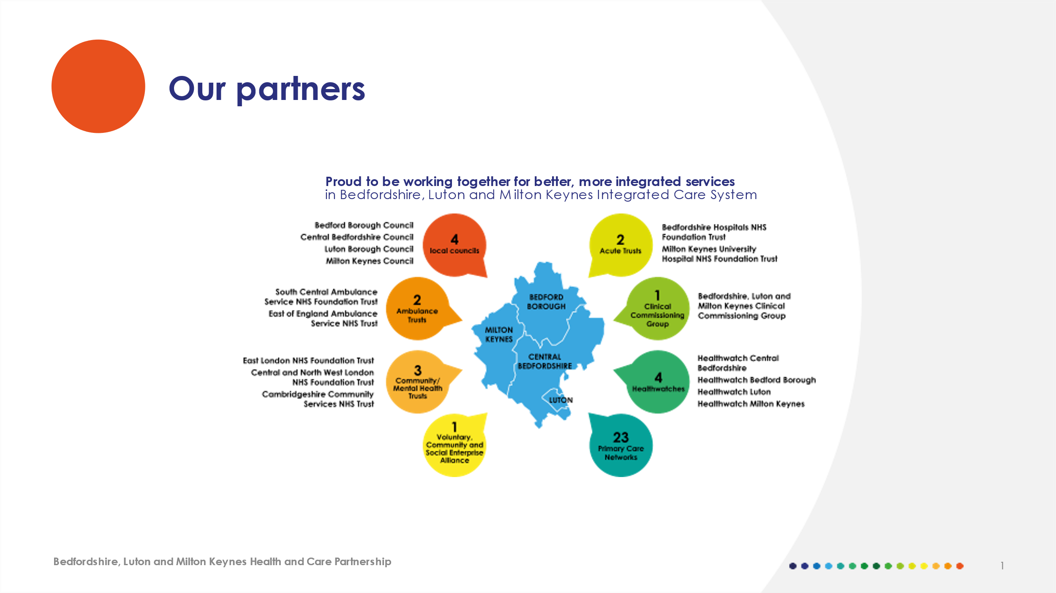
From midnight on 30 June 2022 the Clinical Commissioning Group (CCG) will no longer exist as its functions will be absorbed within the ICB.
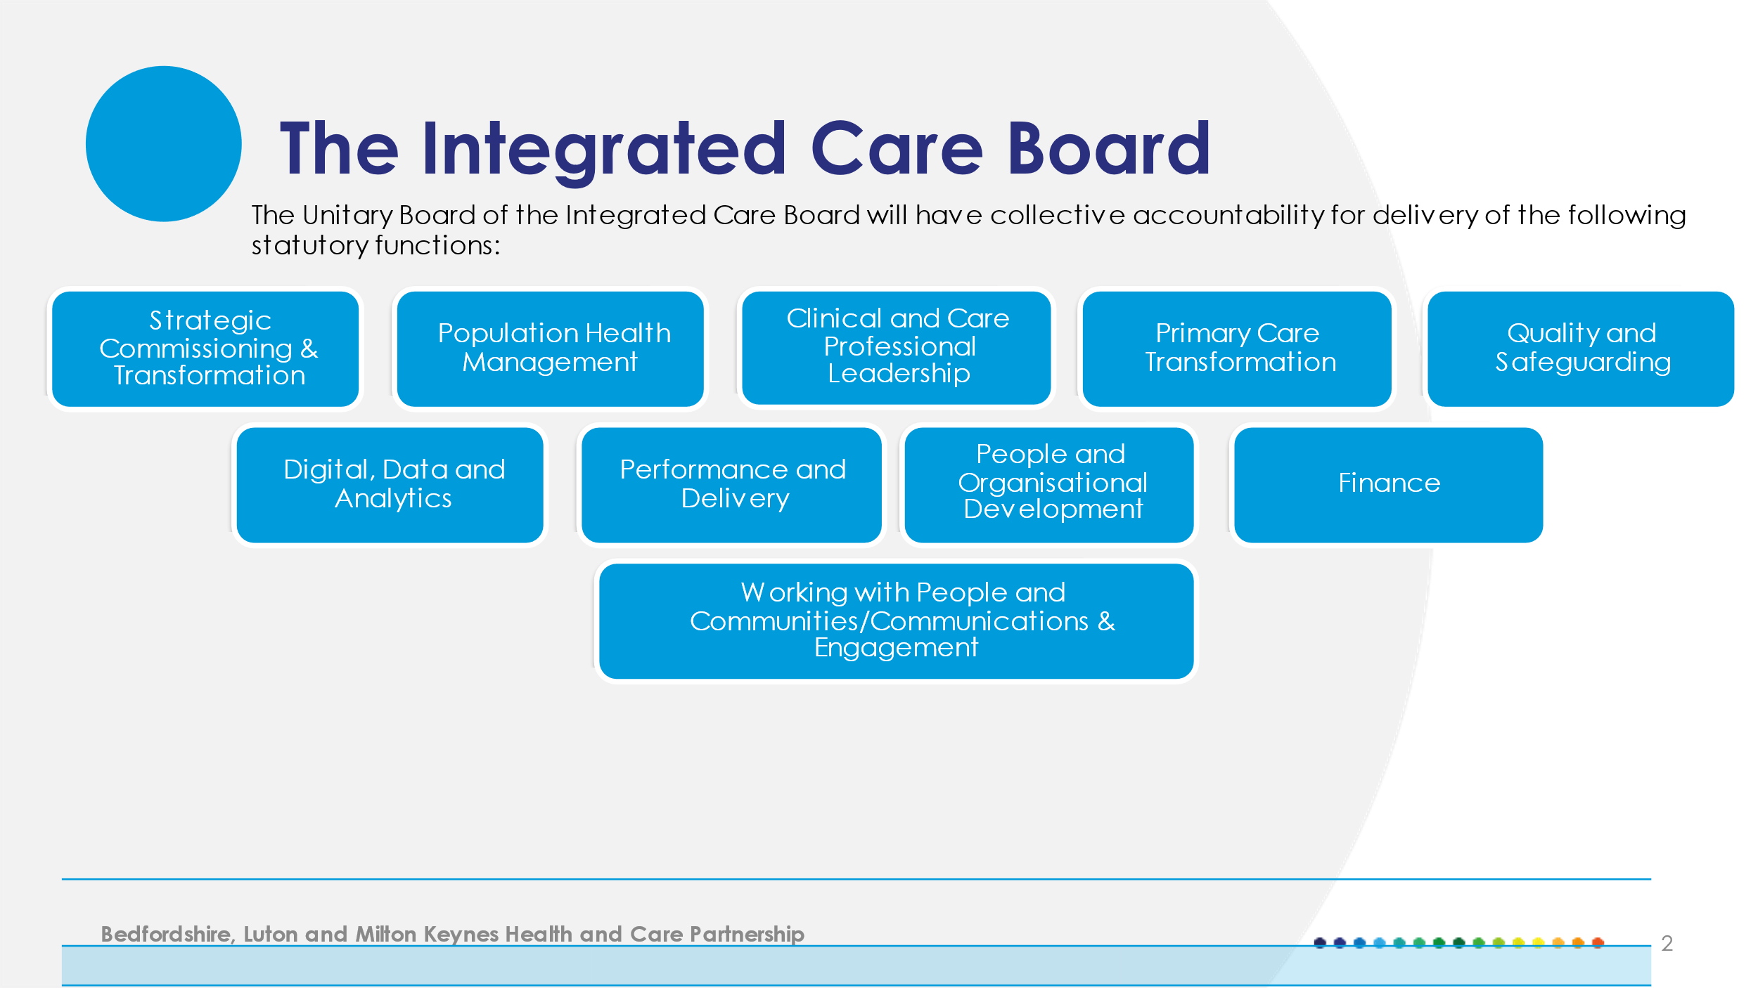

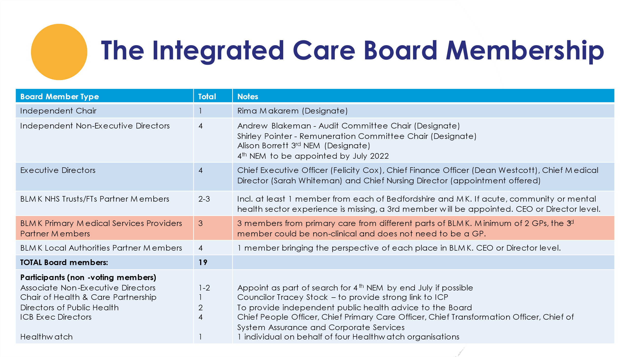
- The Opportunity. The role of the Non-Executive Member

Bedfordshire Luton and Milton Keynes Integrated Care Board will comprise both Executive and Non-Executive Directors. The Board is collectively responsible for the exercise of powers and the performance of the organisation including:
- Setting strategic direction and ensuring management capacity and capability.
- Providing leadership to the organisation and Integrated Care System.
- Ensuring the services delivered are developed in collaboration with our stakeholders and importantly, with our local population.

Non-Executive Member

All Board Directors, both Executive and Non-Executive, have a responsibility to challenge constructively in reaching decisions of the Board and to help develop proposals on priorities, risk mitigation, values, standards, and strategy.

Our Non-Executive Members (NEMs), including the Chair, are drawn usually from the local community. They play a crucial role in bringing an independent perspective to the Integrated Care Board, in addition to any specific knowledge or skills they may have.

Working from a basis of improving population health management, NEMs bring partners in the ICS together in a complex political environment with the ability to influence the group of stakeholders who make up the Board.

They contribute to the development of the ICB’s strategy and play an important role in scrutinising the achievement of agreed goals and objectives. They also monitor and assure the quality, efficiency, and safety of service performance. They bring the voice of the public to decision-making processes and ensure that the interests of patients remain at the heart of Board discussions.
Non-Executive Members are also members of the ICB’s Nomination and Remuneration Committee and work with the Chair in the appointment and remuneration of the Chief Executive and other Executive Directors.

The Non-Executive Members are accountable to the Chair of the ICB and participate in an annual evaluation of their performance.

So, what are we looking for in our next NEM?

We have already recruited three great non-executive members and are now looking for a fourth.

However, we are aware some key skills and experience are missing on our Board. Therefore, we are looking for someone experienced in engaging with our local communities and in tackling social justice. You might also bring expertise in digital health technology, finance, local government, or the voluntary and charitable sector. Please note: You do not need to have prior knowledge of the NHS.

On a personal level, you will bring a range of professional expertise as well as community understanding and experience to the work of the Board.

We are interested in your life experience and personal motivations that will add valuable personal insights such as: being a patient, carer, or service user; experience of gender and women’s issues; engaging with diverse social, economic, and cultural groups and communities; experiences and challenges of younger people; and those with lived experience of mental health issues and/or living with physical chronic conditions or disability.

The successful candidate will be a voting member of the Bedfordshire, Luton, and Milton Keynes Unitary Integrated Care Board. They may be required to chair a sub-committee of the Board, and this will be agreed with the Chair. Previous experience of chairing will help them to review and develop good corporate governance.

Associate Non-Executive Members

The Associate Non-Executive Member (Associate NEM) role is used successfully in the NHS to support Board succession strategy and achieve a balance of Board level skills.

The Associate NEM roles are a ‘step up’ role aimed to attract potential Non-Executive Member candidates who do not yet have sufficient or any Board-level experience but have the ability and potential to succeed in a Board-level role.

This is a developmental post for someone from an underrepresented group in our community looking to take the next step in their career, and they will be trained and mentored to succeed in that journey.

For the avoidance of doubt, Associate Non-Executive Members are not voting Board members and do not have the associated rights or liabilities. Instead, they have the ability to learn and influence to operate as a full member of the team but without the same degree of accountability.

The specific skills and background we are looking for in the Associate NEMs are similar to those outlined as above for the NEM.

Diversity and the need for better inclusion

The Integrated Care System needs diverse, inclusive, and compassionate leaders who not only reflect the community they serve, and the staff employed but who also have the leadership style and breadth of perspective to make good collective decisions.

There is emphatic evidence that diverse boards make the best decisions. We want to increase the diversity of our Board team. In non-executive roles nationally, it is known that women, people from the local Black Asian and Minority Ethnic communities, LGBTQ+ communities, younger people, and those with lived experience of disability are all under-represented. We want a change. We are really interested in receiving applications from people with different backgrounds, skills, and experience.

- About us in BLMK ICS

The Bedfordshire Luton and Milton Keynes (BLMK) Integrated Care System (ICS) is a partnership of public sector organisations including the NHS and local councils that are working together to help people live longer and healthier lives.

Ours is a vibrant area, rich in cultural heritage and diversity, but there is poor health and inequality within our boundaries. Our vision is to work with our communities to optimise health and wellbeing, advance equality and make the best use of our resources.

We want people to live longer in good health and we are absolutely committed to spending public money wisely on the services that will make the biggest difference.

We put working together at the heart of our work and develop our plans through discussions with local people to ensure that local voices inform all our decisions. Established as part of the first wave of ICSs in 2017, the BLMK ICS Partnership is well established and is already seeing the benefits of integration.

A track record of achievement

BLMK has a track record of successful partnership working, and in the last eighteen months, the system has worked closely together to deliver an integrated Covid response. The learning from this work has been retained and has led to closer working partnership to benefit our population.

Outside of the pandemic response, BLMK has been successful in bidding for national funding to deliver innovations locally. Recent successes include funding for a social prescribing programme for children and young people, along with significant investment in Child & Adolescent Mental Health Services (CAMHS) support, which will be rolled out through schools.

In addition, we have started to improve our estates, which has led to capital build programmes for both our acute hospitals and the establishment of a new multi-disciplinary Health Hub in Dunstable, Central Bedfordshire.

There is also a strong focus on digital innovations including the Shared Care Records programme, which will allow for integration and data sharing between different organisational systems.

Transforming services to provide the care that residents want is central to our ambition, engaging with people and communities so that they can shape the services they need. In the last two years, we have worked across the system to share intelligence and contacts for community groups, so that we can actively engage residents in an on-going conversation about their health and wellbeing.

As the Integrated Care System establishes, our focus is to use insights, intelligence, and data to identify trends and increase the opportunities for public involvement in how we deliver care and improve outcomes in BLMK.

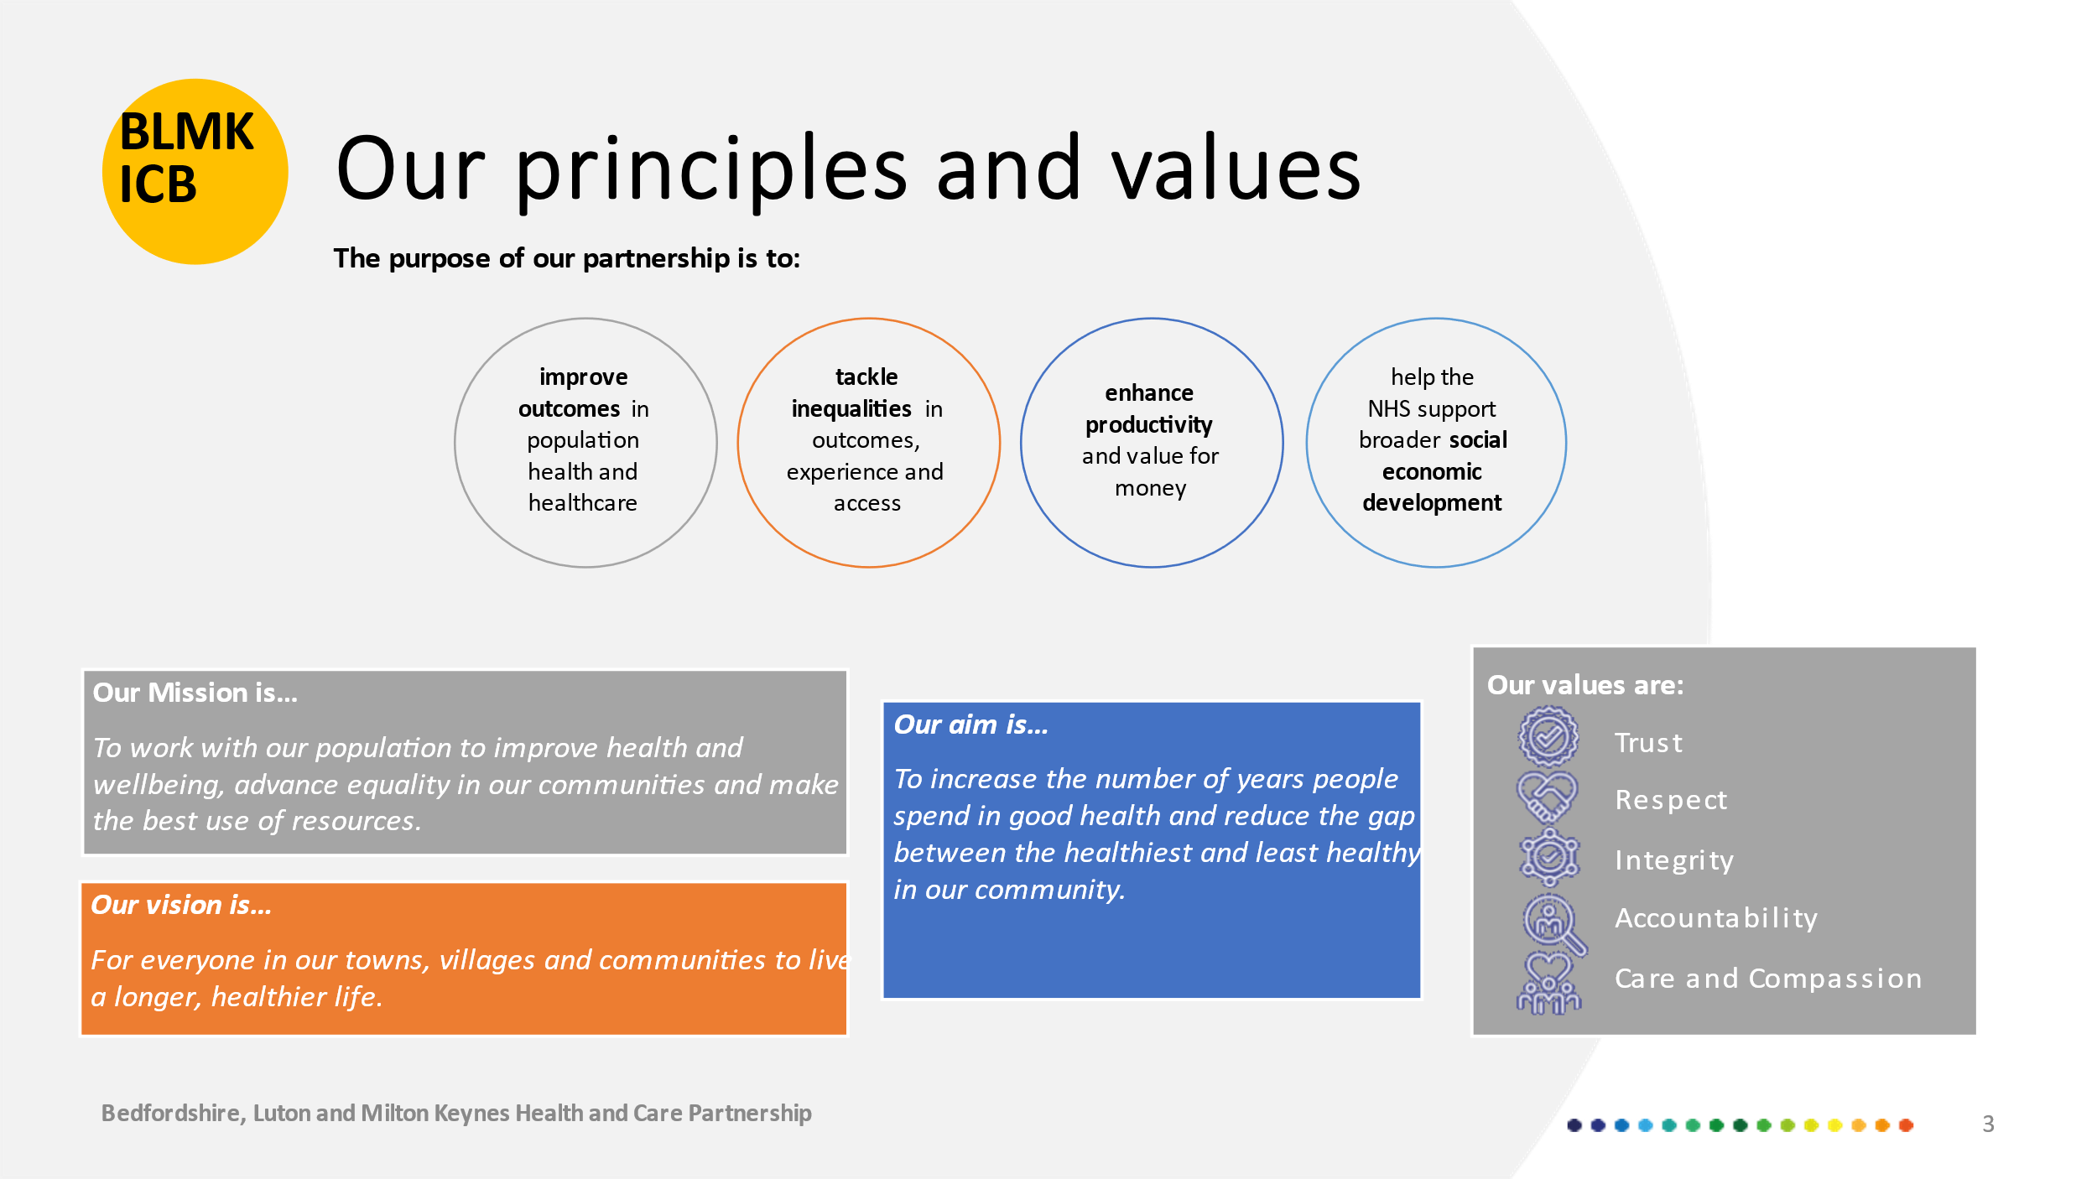

Our vibrant places

Almost one million people live in Bedfordshire Luton and Milton Keynes. The area comprises of four very different and diverse places, Bedford Borough, Central Bedfordshire Luton, and Milton Keynes.

The differences between our places affect what local people need from their health and social care services and each area has a unique set of challenges in terms of population and health issues.

Introducing Luton
Population 218,045

Luton is the most urban, most deprived, and ethnically diverse of the four local authority areas. It is one of the most populated towns without city status in the UK and 47% of the population is made up of ethnic groups.

The town has a rich heritage steeped in artistic skill, including the once vibrant hat making industry and the Vauxhall car factory, which continues to be a major employer in the town. London Luton Airport has undergone significant redevelopment in recent years, flying to ever more destinations. It is the number one airport for private aviation in the country.
The movement of the successful Luton Town Football Club to a new site will be at the heart of the town’s regeneration – bringing a much-needed boost to the economy of £250 million annually. Luton has a strong heritage and strong institutions, and the Council is committed to restoring economic vitality to the town and eradicating poverty by 2040.

Introducing Bedford Borough
Population 173,237

Bedford Borough is one of the largest urban areas in the county of Bedfordshire and one of the most cosmopolitan. Up to 75% of the Borough’s population live in Bedford and the surrounding villages, and there is significant diversity, with 100 different community languages spoken in the Borough and one of the largest concentrations of Italian immigrants in the UK.

The River Ouse passes through Bedford and is a focal point in the town, every two years the town hosts the Bedford River Festival, which attracts around 250,000 visitors. The town has had a rich heritage in the lace industry, brewing and aircraft building, as well as being a popular location for the film industry.

Bedford Borough has an elected Mayor, and is a railway commuter town being just 40 minutes away by rail from London.

Introducing Central Bedfordshire
Population 285,931
Central Bedfordshire is the most rural and least deprived of the four areas. The area comprises 62 small market towns and villages from Sandy in the north to Dunstable in the south.

It is known for its countryside of rolling hills and attracts visitors to its notable tourist attractions, not least Whipsnade Zoo, which is the largest zoo in Europe in terms of hectares.

Woburn Abbey is situated in the area, and it is also the home of the Woburn Deer Farm. Dunstable is known for its Chalk Hills and the Dunstable Downs, London Flying Club, and annual Kite Festival.

The rural and extensive area covered by Central Bedfordshire Council means that there is not one central acute hospital and 30% of residents travel out of area for secondary care, many accessing hospitals outside of the BLMK region.

Introducing Milton Keynes
Population 245,404
Milton Keynes was established 50 years ago when Government set about regenerating towns to relieve housing congestion in London. It successfully gained city status in May 2022 to mark the Queen’s Platinum Jubilee.

Milton Keynes is unique, it has characteristic USA-style grid roads and squares with planting, parkland and lakes used to separate districts. And has grown from a small village and is now the largest place in Buckinghamshire with one of the most successful economies in in the UK – ranking the fifth highest in terms of business start-ups in the country.

Despite this economic success, there are pockets of poverty leading to high levels of deprivation, homelessness, and domestic abuse. Milton Keynes has the youngest population of all our places. Up to 25.3% of the Borough’s population are under 18 and just over13% are over the age of 65 years. The city is well connected to the rest of the country by road and rail, and it is also home to the famous Bletchley Park.

A changing landscape in the area

Large housing developments are being planned and completed, with demand driven in part by the Oxford-Cambridge Arc. The population of BLMK continues to increase, therefore, with a forecast growth of more than 8% by 2031. The ambition of partners within the Integrated Care System is to ensure that as our population grows, residents continue to live healthy and happy lives.

Although people are living longer, they are spending many years in poor health. There is also a difference in life expectancy between those living in our most deprived communities compared to the most affluent ones.
Our purpose and priorities

Our goal in everything we do is to reduce health inequalities and improve outcomes for the residents of Bedfordshire, Luton and Milton Keynes and the communities we serve – adding years to life and life to years. The BLMK Integrated Care System is working hard to give local people the health and care services they need and deserve, both now and into the future.

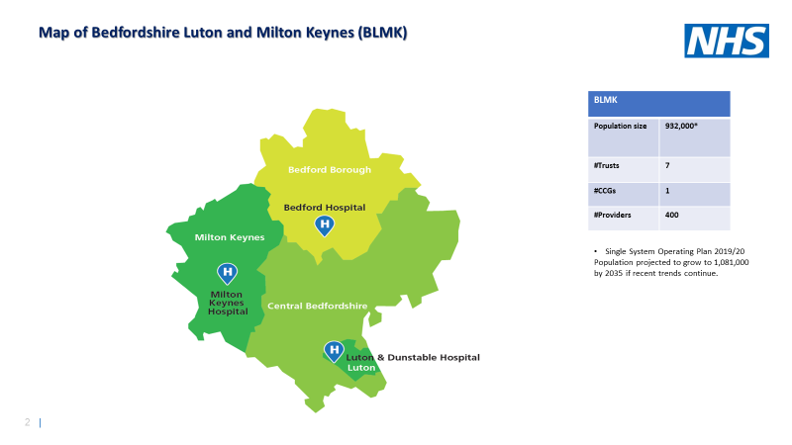

Our strategic priorities are:

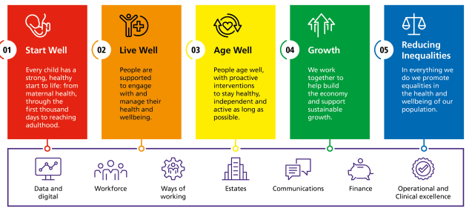

For more information, please refer to our website at: https://blmkhealthandcarepartnership.org/about/your-ics-partnership-board/

- BLMK ICS Leadership and ICS Establishment

Dr Rima Makarem is the Chair or the BLMK Integrated Care System since June 2020, having been appointed through open recruitment.

Dr Makarem is currently supported by a Transitional ICS/Clinical Commissioning Group (CCG) Leadership Team to deliver the programme of work to establish the statutory BLMK Integrated Care Board and Integrated Care Partnership by 1 July 2022.

Following a national recruitment process, Felicity Cox became the ICB’s Chief Executive Officer Designate earlier in 2022. She had been appointed as ICS lead and CCG accountable officer on 1 December 2020.

Independent Non-Executive Members
for proposed Bedfordshire, Luton, and Milton Keynes Integrated Care Board

Job Description and Role Profile for:

1 x Non-Executive Member

2 x Associate Non-Executive Members

Role responsibilities and competencies
You will work alongside the Chair, other non-executives, executive directors and partner members and as equal members of a unitary board. You will be responsible for specific areas relating to board governance and oversight:

- Bringing independent and respectful challenge to the plans, aims and priorities of the ICB.
- Promoting open and transparent decision-making that facilitates consensus aimed to deliver exceptional outcomes for the population.
Personally, you will bring a range of professional expertise as well as community understanding and experience to the work of the Board. You might be experienced in engaging with our local communities and in tackling social justice. You might also bring expertise in digital health technology, finance, local government, or the voluntary and charitable sector. Please note: You do not need to have prior knowledge of the NHS.

We are interested in your life experience and personal motivations that will add valuable personal insights such as, being a patient, carer, or service user; experience of gender and women’s issues; engaging with diverse social, economic, and cultural groups and communities; experiences and challenges of younger people; and those with lived experience of mental health issues and/or living with physical chronic conditions or disability.

Alternatively, you may be highly skilled and experienced with digital solutions and applications. These are valuable skills and knowledge as healthcare technology continues to develop - if this is your area of expertise - we welcome your application.

As an ICB leader, you will demonstrate a range of leadership competencies as outlined below. Corporately, as members of a unitary board, you will contribute to a wide range of areas including:

The Model Specification for a Non-Executive member

Competency | Knowledge, Experience and Skills required
Setting strategy and  delivering long-term transformation | Knowledge of health, care, local government landscape and/ or the voluntary sector.  A capacity to thrive in a complex and politically charged environment of change and uncertainty.  Experience leading change at a senior level to bring together disparate stakeholder interests.
Building trusted relationships with  partners and communities | An understanding of different sectors, groups, networks, and the needs of diverse populations.  Exceptional communication skills and comfortable presenting in a variety of contexts.  Highly developed interpersonal and influencing skills, able to lead in a creative environment which enables people to thrive and collaborate.  Experience working collaboratively across agency and professional boundaries.
Leading for Social  Justice and health equality | An awareness and appreciation of social justice and how it might apply within an ICS.  Record of promoting equality, diversity, and inclusion in leadership roles.  Life experience and personal motivation that will add valuable personal insights.
Driving high quality, sustainable outcomes | Problem solving skills and the ability to identify issues and areas of risk, leading stakeholders to effective resolutions and decisions.
Providing robust governance and  assurance | An understanding of good corporate governance.  Ability to remain neutral to provide independent and unbiased leadership with a high degree of personal integrity.  Experience contributing effectively to complex professional meetings at a very senior level.
Creating a  compassionate and inclusive culture for our people | Models respect and a compassionate and inclusive leadership style with a demonstrable commitment to equality, diversity, and inclusion in respect of boards, patients, and staff.  Creates and lives the values of openness and transparency embodied by the principles-of-public-life and in Our People Promise.

Essential Knowledge & Skills for the 4th Non -Executive Member role

Essential skills & Knowledge | NEM | Associate NEM
1.Communication skills, in particular ability to hold discussions with a wide variety of community representatives | Essential | Desirable
2. Knowledge of health, care, local government landscape and/or the voluntary sector | Essential or desirable? Given that we are looking for a range of possible areas of expertise eg digital | Essential same as for NEM
3. An understanding of different sectors, groups, networks, and the needs of diverse populations | Essential | Desirable - we value the life experience you can bring of your community and groups
4.Record of promoting equality, diversity and inclusion (ED&I) in leadership roles and knowledge of how this relates to social justice | Essential | Life experience of this key area is sought

NEM Committee Chairs

The independent non-executive member, Chair of an ICB Committee:
- Is accountable to the ICB Chair.
- Has designated areas of responsibilities as agreed with the ICB Chair.
- Provides leadership and vision to any agreed committee to ensure that it is effective in its role.
- Ensures the committee identifies key risks in implementing its strategy; determines its approach and attitude to providing effective oversight of those risks and ensures there are prudent controls to assist in managing risk.
- Leads and supports a constructive dynamic within the committee, enabling grounded debate with contributions from all, ensuring the committee sees itself as a team, has the right balance and diversity of skills, knowledge and perspectives, and the confidence to challenge on all aspects of the agenda.
- Guards the committee’s independence as a source of assurance to the board and leads the committee in establishing effective and ethical decision-making processes.
- Has recent and relevant experience with community engagement, social justice, or the application of digital technology in a non-NHS environment
- Has experience operating at senior or board level, or demonstrate the aptitude to do this
- Can demonstrate independent and proactive leadership with confidence and integrity
- Can champion open, frank, and disciplined discussion and be prepared to ask the difficult questions and challenge colleagues

2. Eligibility

You will be able to demonstrate that you meet the requirements of the fit and proper person test (see attached form) and that you have no substantial conflicts of interests that would interfere with your ability to be independent and offer an impartial perspective.

The successful applicants should not have an ongoing leadership role (hold positions or offices) at a partner organisation of the BLMK ICS. You will need to stand down from such a role if appointed to the ICB independent non-executive member role.

Applicants should live within or have strong connections with the area served by the ICS.

Given the significant public profile and responsibility members of NHS boards hold, it is vital that those appointed inspire confidence of the public, patients, and NHS staff at all times. We will undertake a number of specific background checks to ensure that those we appoint are “fit and proper” people to hold these important roles.

More information can be found on our website Home - Bedfordshire, Luton and Milton Keynes (BLMK) Health (blmkhealthandcarepartnership.org)

Applications will be assessed on merit, as part of a fair and open process, from the widest possible pool of candidates. The information provided by applicants will be relied on to assess whether sufficient personal responsibility and competence have been demonstrated in previous/other roles, to satisfy the experience, skills and values being sought.

We value and promote diversity and are committed to equality of opportunity for all. We believe that the best boards are those that reflect the communities they serve.

- 50% of the working age population and 77% of the NHS workforce are women
- 14% of the working age population and 23% of the NHS workforce are from ethnic minorities 16% of working age population and 5% of the NHS workforce are disabled
- 2% of the population over 16 and 3% of the NHS workforce identify as LGBT
- 82% of working age adults and 79% of the NHS workforce are under 55

1 Population data source gov.uk/ons.gov.uk (2011 Census). NHS source: Workforce NHS Digital - Hospital and Community Health Services workforce statistics: Equality and Diversity in NHS Trusts and CCGs in England (2020 September data used)

We want to increase the diversity of our NHS leadership and encourage applications from groups we know are all under-represented in these important roles. We prioritise Equality, Diversity and Inclusion (ED&), team health and wellbeing and the principles of kind leadership in our 'ways of working'. The successful applicants will have a key role in nurturing this culture.

3. Terms of appointment

- The remuneration: For the Non-Executive member it will be £13,000 per annum, rising to a maximum of £16,000 per annum if a committee is chaired.
- The term of office as ICB independent Non-Executive member will be in line with the ICB constitution which states an initial period of up to three years, with the potential for a renewed term of a further three years.
- On average, it will require a minimum of three days a month, including preparation time such as reading papers, the occasional evening engagement and events designed to engage with the community or support your continuous development. The majority of Board meetings must be attended as should any committees you are assigned to.
- The Associate Non-Executive member will for an initial period of two years after which a review will take place and a discussion about next steps to a full Non-Executive member role (subject to vacancies).
- Remuneration is £6,500 per annum. It is expected that you will be available for one and half to two days per month to participate in Board and Committee meetings, in community events and professional development.

- More information in support of your application

We are conscious this may be the first time you have considered applying for such a role as this. To support you we are offering several virtual ‘drop in’ events so we can answer any questions you may have included who to speak to for additional background information, and how to write a suitable application.
In addition, you can speak with the Chair, Dr Rima Makarem who will be delighted to tell you more about becoming a member of the Board.

- Making an application
For more information, please contact a.malciw@nhs.net to arrange conversation with Chair Designate, Dr Rima Makarem.

All applications should be sent to: blmkccg.icbrecruitment@nhs.net

The closing date is midnight on Sunday 19 June 2022.

Virtual drop-in sessions will be held on Tuesday 7 June 2022 at 6pm and Monday 13 June at 12 noon.

The panel interview will be held during the first week in July 2022. A date and time will be confirmed with shortlisted candidates. Please let us know if there are any dates you cannot make in your application.

We intend to hold the interviews face to face at our offices on Sherwood Drive, Bletchley, Milton Keynes. If you are unable to attend a face-to-face interview, please indicate this in your covering statement and we will look at other options.

Closing date for applications: Midnight on Sunday 19 June 2022

If you wish to be considered for one of the ICB designate independent Non-Executive member roles, please provide:

• Confirmation of the designate ICB non-executive role you are applying for (NEM or Associate NEM). We strongly advise that you tailor and submit individual applications to be competitive
• A CV that includes your address and preferred contact details, highlighting and explaining any gaps in your employment history. Please note that we also consider unpaid employment as suitable experience when shortlisting for these roles.
• A supporting statement that highlights your skills and experience and tells us why you want this role and what positive difference you would make to the BLMK community if appointed to this role. You should also outline your personal responsibility and achievement within previous roles that demonstrates you have the knowledge, skills, and competencies to deliver this role, as outlined in the person specification
• The names, positions, organisations and contact details for three referees. Your referees should be individuals in a line management capacity, senior stakeholders, or other suitable professional referee, and cover your most recent roles and employer, any regulated health or social care activity or where roles involved children or vulnerable adults. Your references will be taken prior to interview and may be shared with the selection panel
• You will also be asked to complete the enclosed diversity monitoring form and answer some questions about criteria that may disqualify you from appointment.
• Tell us about any dates when you will not be available for the selection process.

Shortlisting: the selection panel will use the information provided by the applicants and feedback from any preliminary assessment to agree applicants invited to interview. Assessment will be based on merit against the competencies experience, skills and values outlined in the person specification.

Interviews: if invited to interview, applicants will be asked to make a 5 to 10-minute verbal presentation (no slides will be necessary) to help the selection panel draw out the competencies, experience, skills, and values outlined in the person specification. The formal interview will then be 45 mins to an hour of open questions from the selection panel to showcase experience and explore applicant’s values, motivations, creativity, and ability. You will also be given an opportunity to ask the panel questions about the role and organisation.

If you have a valid reason for not being able to attend a face-to-face interview, please tell us why on the application and we can look to arrange a virtual interview with you provided you have access to a computer and an internet connection.

Appointment: Selection panels will be asked to identify appointable candidates based on merit against the competencies experience, skills and values outlined in the person specification. The preferred candidate will be referred to NHS England and Improvement Regional Team, East of England for approval before final appointment by the inaugural meetings of the relevant ICB.

