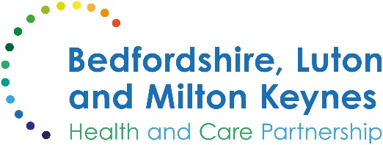

MEDIA RELEASE

13 December 2024

Senior local therapist offers advice on avoiding falls this winter

A senior local occupational therapist has urged older residents in Bedfordshire, Luton and Milton Keynes to take extra care this winter to reduce the risk of falls.

Falls can have significant consequences on an individual’s health, wellbeing and independence. As people age, this risk increases notably, with around one-third of those aged 65 and over experiencing a fall each year. For those aged 80 and over, the likelihood of falling rises to almost 50%.

Residents, families and carers can find reducing the risk of a fall through following 10 simple steps:

- Keep your home well-lit: Ensure all rooms, passages, and staircases are well-lit to help you move safely.
- Remove clutter and hazards: Immediately mop up spillages, remove clutter, trailing wires, and frayed carpets.
- Use non-slip mats and rugs: Place non-slip mats and rugs in areas prone to wetness, such as the bathroom.
- Wear appropriate footwear: Wear well-fitting, non-slip shoes that support the ankle.
- Stay active: Engage in regular strength and balance exercises, such as tai chi, walking, or dancing.
- Have regular eye tests: Regular eye tests can help identify vision problems that might increase your risk of falling.
- Review your medications: Have your medications reviewed regularly to identify any that might increase your risk of falls.
- Take care when walking outside: Be cautious on icy or snowy surfaces and consider using walking aids if needed.
- Stay warm: Keep your home warm and avoid going out in icy or snowy conditions.
- Use personal alarms: Consider using a personal alarm system to signal for help in case of a fall.

Lawrence Fung, an occupational therapist who is falls prevention lead at Milton Keynes University Hospital, said:

“As we head into the colder months, it's essential to take steps to prevent falls. Simple measures such as keeping your home well-lit, removing clutter and wearing non-slip shoes can make a big difference. Staying active with strength and balance exercises, such as tai chi or chair-based exercises, can also help you to maintain stability and reduce your risk of falls. Remember, falls are not an inevitable part of aging, and with the right precautions, we can all stay safe and independent this winter.

“Whether you are an older person, carer, family member, friend, or healthcare professional, take time to understand the risks in and around your home, and take measures to reduce them.”

If you have experienced a fall before, making changes to reduce your risk of falling again can also help alleviate any fear of falling. Lots more advice and information are available on the NHS website.

ENDS

NOTES TO EDITORS

About the Bedfordshire, Luton and Milton Keynes Integrated Care Board
The Bedfordshire, Luton and Milton Keynes Integrated Care Board is responsible for planning the delivery of health care for a population of one million people across four diverse local authority areas – Bedford Borough, Central Bedfordshire, Luton and Milton Keynes.

Our aim is simple. We want everyone who lives in our city, towns, villages and communities to live a longer, healthier life. Our strategic priorities are set out below.

Bedfordshire, Luton and Milton Keynes support two million jobs locally and we are one of the fastest growing economies in England, contributing £110bn to the UK economy.

We represent a diverse population, with 47% of residents in Luton coming from an ethnic minority background and while there is affluence in the more rural communities of Central Bedfordshire, some of our wards are amongst the most deprived in the country.

