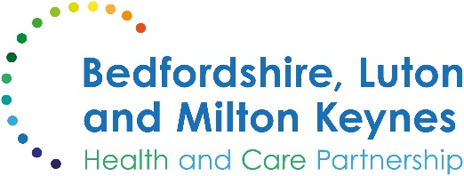

MEDIA RELEASE

27 November 2024

Data show more general practice appointments in Bedfordshire, Luton, and Milton Keynes

New figures from NHS England show another big rise in the number of appointments offered at general practices in Bedfordshire, Luton and Milton Keynes.

Practices in the region have provided over 4,362,000 appointments so far in 2024, an increase of over 224,000 (5.4%) compared with the previous year.

The most recent data show that between July and September 2024, there were over 1,468,000 appointments made with practices in Bedfordshire, Luton and Milton Keynes, compared with 1,401,000 in the same three-month period in 2023, a rise of around 4.8%.

Felicity Cox, chief executive officer of Bedfordshire, Luton and Milton Keynes Integrated Care Board, said:

“I am delighted to see the continued growth in the number of appointments available at general practices in Bedfordshire, Luton, and Milton Keynes.

“This increase shows the commitment of local practices to addressing the healthcare needs of local people. By enlarging and diversifying the primary care workforce, such as more pharmacists, paramedics and physiotherapists, practices are able to offer more appointments and ensure that patients see the right professional at the first time of asking.”

ENDS

NOTES TO EDITORS

About the Bedfordshire, Luton and Milton Keynes Integrated Care Board
The Bedfordshire, Luton and Milton Keynes Integrated Care Board is responsible for planning the delivery of health care for a population of one million people across four diverse local authority areas – Bedford Borough, Central Bedfordshire, Luton and Milton Keynes.

Our aim is simple. We want everyone who lives in our city, towns, villages and communities to live a longer, healthier life. Our strategic priorities are set out below.

Bedfordshire, Luton and Milton Keynes support two million jobs locally and we are one of the fastest growing economies in England, contributing £110bn to the UK economy.

We represent a diverse population, with 47% of residents in Luton coming from an ethnic minority background and while there is affluence in the more rural communities of Central Bedfordshire, some of our wards are amongst the most deprived in the country.

