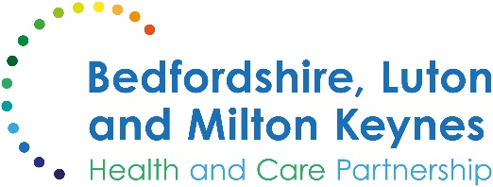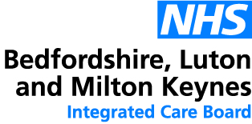

MEDIA RELEASE

06 January 2025

Beat the cost of living crisis with help towards your health costs

Although most NHS treatment is free, there are still some costs you might need to pay.

With many households still struggling with the cost of living, however, you may be able to get help to pay for some health costs. Prescriptions, dental care and eye care are among the most common areas, but you may also be able to claim back the cost of travel to your tests or treatment.

In England, prescriptions are free for people in a number of groups. The largest categories are age-related: you don’t need to pay if you’re aged 60 and over, or if you’re under 16 (or aged 16-18 and in full-time education).

If you’re pregnant or have had a baby within the last 12 months, you can apply for a maternity exemption certificate which covers all your prescriptions (as well as dental costs). People with certain medical conditions and disabilities are also exempt from these costs, but you do need to obtain the relevant certificate which you can present at your pharmacy or other health service. You may also be entitled to free prescriptions if you have a war pension exemption certificate.

It’s also worth checking your eligibility if you and/or your partner receive some payments such as Income Support, Universal Credit and Pension Credit. People who receive any of these may also be entitled to help with travel costs to some health appointments under the Healthcare Travel Costs Scheme.

If you’re not eligible for free prescriptions but you are expecting to need lots of prescription items over a short period, it may be more cost-effective to get a prescription pre-payment certificate (PPC). This works like a season ticket, and there are three options to choose from:
- The 3-month PPC costs £32.05 and will save you money if you need more than three prescribed items in 3 months.
- The 12-month PPC costs £114.50 and will save you money if you need more than 11 prescribed items in a year.
- The hormone replacement therapy (HRT) PPC costs £19.80 and will save you money if you need more than two prescribed HRT items in a year.

NHS dental care can also leave an unexpected hole in your family finances, but help is at hand. You'll only ever be asked to pay a single charge for each complete course of treatment, even if you need to visit your dentist more than once to finish it. The NHS website has lots more information on dental costs and eligibility for help.

Fiona Garnett, associate director of pharmacy and medicines optimisation at Bedfordshire, Luton and Milton Keynes Integrated Care Board, said:

“Many people are entitled to help with their health costs but may not realise it. Because we want to make sure that the help goes to those who most need it, we carry out regular checks on treatments which are not paid for. Dishonestly claiming free care when you’re not entitled to it may lead to prosecution and a criminal record.

“For more information on any of these schemes and to check your current eligibility, please see the Help With Health Costs section of the NHS website. You can apply online for many of the certificates and exemptions which the NHS offers, and it’s especially worth checking if your circumstances have changed recently or if someone in your household has passed a landmark birthday.

“The cost of living has gone up a lot in the last few years, so a little bit of help with your family’s health costs may make a world of difference. Never be afraid or embarrassed to claim what you’re entitled to: the help is there for a reason, and it’s yours.”

ENDS

NOTES TO EDITORS

More information on help with health costs
The NHS website contains a list of exemptions and entitlements, as well as forms to claim a refund if you think you are entitled to a refund of a fee you’ve paid, and a list of useful telephone numbers.

About the Bedfordshire, Luton and Milton Keynes Integrated Care Board
The Bedfordshire, Luton and Milton Keynes Integrated Care Board is responsible for planning the delivery of health care for a population of one million people across four diverse local authority areas – Bedford Borough, Central Bedfordshire, Luton and Milton Keynes.

Our aim is simple. We want everyone who lives in our city, towns, villages and communities to live a longer, healthier life. Our strategic priorities are set out below.

Bedfordshire, Luton and Milton Keynes support two million jobs locally and we are one of the fastest growing economies in England, contributing £110bn to the UK economy.

We represent a diverse population, with 47% of residents in Luton coming from an ethnic minority background and while there is affluence in the more rural communities of Central Bedfordshire, some of our wards are amongst the most deprived in the country.

