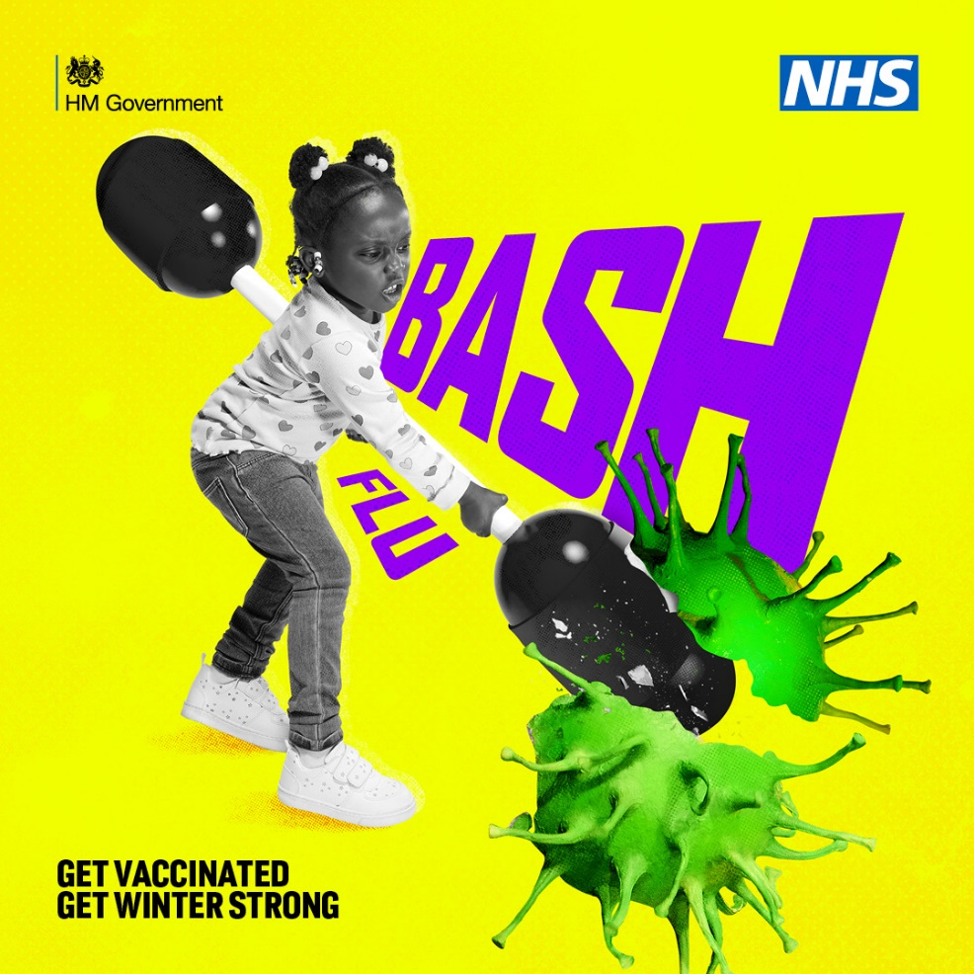

Bash flu. Get vaccinated.
Get winter strong. If your child was aged 2 or 3 on the 31 August 2024, get their free flu vaccine.
Check eligibility and how to book at nhs.uk/child-flu.

