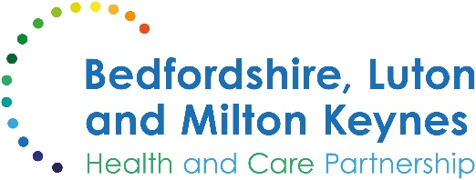

MEDIA RELEASE

15 November 2024

Be prepared: Residents encouraged to stock up medicine cabinet ahead of Winter

A senior local pharmacist is urging people in Bedfordshire, Luton and Milton Keynes to make sure they have ample supplies of key medication and medical supplies to stay well this winter.

A properly stocked medicine cabinet can help treat many common illnesses and ailments over the cold winter months – avoiding the need to have to travel to your local pharmacy or practice when you’re feeling at your worst.

Important items include:
- A first-aid kit, including bandages, plasters, a thermometer, antiseptic, eyewash solution, sterile dressings, medical tape for dressings and tweezers;
- Pain relief such as aspirin, paracetamol and ibuprofen for aches, pains and high temperatures;
- Oral rehydration salts to replace lost minerals and fluid after a fever or vomiting and diarrhoea;
- Anti-diarrhoea tablets to relieve symptoms of diarrhoea, although these will not help with the underlying cause;
- Antihistamines which can help with allergies;
- Indigestion relief remedies.

Fiona Garnett, associate director of pharmacy and medicines optimisation at Bedfordshire, Luton and Milton Keynes Integrated Care Board, is encouraging everyone to double check their supplies of self-care medicines at home. She said:

“During the winter months, it’s common to experience minor illnesses, and having a well-stocked medicine cabinet with self-care medicines that can help alleviate symptoms or recover more quickly.

“With winter approaching, it's essential to ensure that your medicine cabinet is well-stocked with necessary supplies of self-care medicines. This proactive step can help you manage minor illnesses at home and avoid unnecessary trips to healthcare facilities.

“Keeping a range of over-the-counter medications, such as pain relievers, cold and flu remedies, and any regular prescription medications, ensures you're prepared for common winter ailments. Being prepared means you can quickly address any health concerns without having to make a needless trip to purchase medicines and recover faster, allowing you to enjoy the winter season with peace of mind.”

To find out more about the services available to you this winter, visit the BLMK ICB website here.

ENDS

NOTES TO EDITORS

About the Bedfordshire, Luton and Milton Keynes Integrated Care Board
The Bedfordshire, Luton and Milton Keynes Integrated Care Board is responsible for planning the delivery of health care for a population of one million people across four diverse local authority areas – Bedford Borough, Central Bedfordshire, Luton and Milton Keynes.

Our aim is simple. We want everyone who lives in our city, towns, villages and communities to live a longer, healthier life. Our strategic priorities are set out below.

Bedfordshire, Luton and Milton Keynes support two million jobs locally and we are one of the fastest growing economies in England, contributing £110bn to the UK economy.

We represent a diverse population, with 47% of residents in Luton coming from an ethnic minority background and while there is affluence in the more rural communities of Central Bedfordshire, some of our wards are amongst the most deprived in the country.

