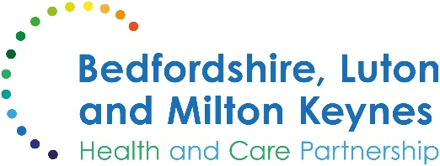

MEDIA RELEASE

16 December 2024

Advice for parents on common childhood winter illness

A senior local nurse has urged parents to prepare for common illnesses which children often experience during the winter months.

Understanding these winter ailments and how to manage them is crucial for keeping your child comfortable and healthy. In most cases, parents can manage their child's winter illnesses at home with over-the-counter medication to ease symptoms, plenty of rest, fluids, and tender loving care. If your child's symptoms are concerning or unfamiliar, a pharmacist may provide valuable advice. If you're still worried, it's best to see a GP.

If your child falls ill at night, you can visit NHS 111 Online, or call 111 for urgent medical advice for conditions which aren’t life-threatening.

Charlotte Nunn, division chief nurse of paediatrics at Milton Keynes University Hospital, said:

"As winter approaches, it's important for parents to be vigilant about their children's health. Common winter illnesses like colds, flu, and bronchiolitis can be managed at home with rest, fluids, and over-the-counter medications. However, if you're ever unsure or concerned about your child's symptoms, don't hesitate to seek advice from your pharmacist, GP or NHS 111.

“Your instincts as a parent are powerful, and we're here to support you every step of the way."

Bedfordshire, Luton and Milton Keynes Integrated Care Board has also reissued its popular guide to children’s health ahead of the holiday season. It contains information on common symptoms and the recommended actions parents can take to get the appropriate help for a sick child.

ENDS

NOTES TO EDITORS

About the Bedfordshire, Luton and Milton Keynes Integrated Care Board
The Bedfordshire, Luton and Milton Keynes Integrated Care Board is responsible for planning the delivery of health care for a population of one million people across four diverse local authority areas – Bedford Borough, Central Bedfordshire, Luton and Milton Keynes.

Our aim is simple. We want everyone who lives in our city, towns, villages and communities to live a longer, healthier life. Our strategic priorities are set out below.

Bedfordshire, Luton and Milton Keynes support two million jobs locally and we are one of the fastest growing economies in England, contributing £110bn to the UK economy.

We represent a diverse population, with 47% of residents in Luton coming from an ethnic minority background and while there is affluence in the more rural communities of Central Bedfordshire, some of our wards are amongst the most deprived in the country.

