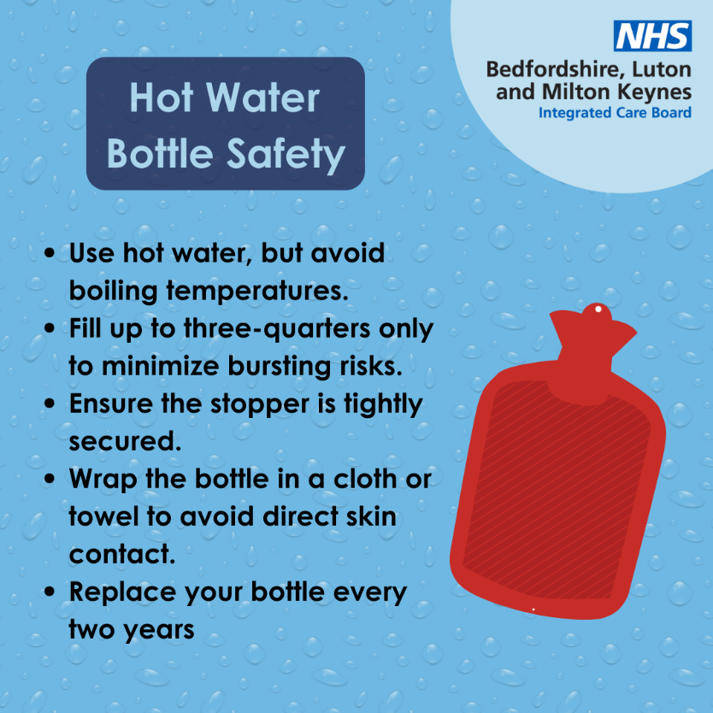

Hot Water Bottle Safety Alert! 🛑
Did you know you should replace your hot water bottle every 2-3 years? This is crucial for your safety, as rubber degrades over time. Most burns from hot water bottles occur because they burst, split, or leak.
Stay safe and warm this winter!

