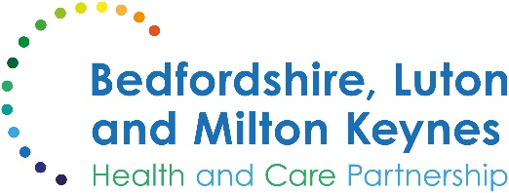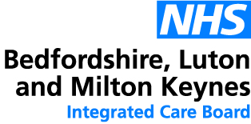

MEDIA RELEASE

11 November 2024

Eligible residents reminded to book in for RSV vaccine

A senior local doctor is reminding eligible residents to book in for the RSV vaccine. This is a new vaccination, available for the first time this year, to those who qualify.

The RSV (Respiratory Syncytial Virus) vaccine is designed to protect against RSV, a common virus that can cause serious respiratory illnesses, especially in babies and older adults. Those eligible for the RSV vaccine include adults aged 75 to 79 and anyone who is pregnant (from 28 weeks onwards).

Dr Sanhita Chakrabarti, deputy chief medical officer at Bedfordshire, Luton and Milton Keynes Integrated Care Board, said:

“RSV is a preventable illness, and it is critically important that we take all necessary measures to protect ourselves and our loved ones. By introducing this new vaccination programme, we are taking a significant step forward in reducing the number of hospitalisations caused by RSV.

“If you’re more than 28 weeks pregnant, I’d encourage you to receive the vaccine to protect your newborn. If you’re aged 75 to 79, you need only one dose for several years of protection against RSV. If you’re eligible, you’ll be invited to come forward by your maternity service or your GP surgery.

“This will not only help to save countless lives but also ease the burden on our healthcare system. It's imperative that we all do our part by getting vaccinated and supporting public health initiatives. Together, we can make a substantial impact and safeguard our communities against this potentially severe illness.”

More information about the RSV vaccine, as well as about all NHS vaccination programmes, is available on the NHS website.

ENDS

NOTES TO EDITORS

About the Bedfordshire, Luton and Milton Keynes Integrated Care Board
The Bedfordshire, Luton and Milton Keynes Integrated Care Board is responsible for planning the delivery of health care for a population of one million people across four diverse local authority areas – Bedford Borough, Central Bedfordshire, Luton and Milton Keynes.

Our aim is simple. We want everyone who lives in our city, towns, villages and communities to live a longer, healthier life. Our strategic priorities are set out below.

Bedfordshire, Luton and Milton Keynes support two million jobs locally and we are one of the fastest growing economies in England, contributing £110bn to the UK economy.

We represent a diverse population, with 47% of residents in Luton coming from an ethnic minority background and while there is affluence in the more rural communities of Central Bedfordshire, some of our wards are amongst the most deprived in the country.

