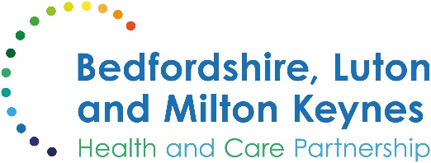

MEDIA RELEASE

25 November 2024

New triage system allows patients to see the right professional at the first time of asking

Many patients at general practices across Bedfordshire, Luton and Milton Keynes are benefiting from a time-saving process which helps them to be seen and treated sooner.

The ‘total triage’ system enables patients to provide more information about their reason for contacting the surgery, which is then reviewed by a clinician, allowing each patient to be offered an appointment with the most appropriate member of the practice team, or signposted to the best service for their need.

This new way or working offers significant advantages, enhancing patient care and helping patients to see the right professional at the first opportunity. With more and more practices offering clinical pharmacy, physiotherapy, counselling and other services, this ensures that the practice can make the best use of professionals’ time and the appointments available.

The system works as follows:
- Initial contact: Patients contact the practice via telephone, online consultation tools, or the front desk (all surgeries are different).
- Information gathering: Patients provide information about their health concerns, which is then evaluated by trained practice staff or a clinician.
- Triage process: The information is used to determine the urgency of the request and the most suitable healthcare professional to handle it. In some cases, this is carried out using digital tools such as online consultation systems, secure messaging or telephone consultations.
- Appropriate care pathway: Based on the triage assessment, patients are offered a face-to-face appointment, a video consultation, or advice and treatment provided remotely by the most appropriate member of the practice team.

Many practices have introduced total triage systems to allow them to allocate resources more effectively, ensuring that the most critical cases receive immediate attention. This will result in patients benefiting from more personalised and accessible care, making use of new technology to offer easier communication and follow-ups. Overall, studies have found that total triage improves patient satisfaction and supports better health outcomes for those who need care and treatment.

If your practice is moving to this system, they will let you know; otherwise, you should continue to seek an appointment as before.

Nicky Poulain, chief primary care officer at Bedfordshire, Luton and Milton Keynes Integrated Care Board, said:

“Total triage is a transformative approach that enables our practices to manage patient demand more effectively, ensuring that everyone receives timely and appropriate care.

“Our leading GPs say that by triaging all patient requests, they can allocate their staff resources most efficiently, reduce waiting times, and maintain high standards of care even during periods of high demand.

“This new approach not only benefits patients, but also supports practice staff and allows GPs to focus on more complex cases. Evidence from other regions shows that total triage creates a more efficient and responsive healthcare environment, benefiting both staff and patients.”

There is more information available online about total triage in the NHS.

ENDS

NOTES TO EDITORS

About the Bedfordshire, Luton and Milton Keynes Integrated Care Board
The Bedfordshire, Luton and Milton Keynes Integrated Care Board is responsible for planning the delivery of health care for a population of one million people across four diverse local authority areas – Bedford Borough, Central Bedfordshire, Luton and Milton Keynes.

Our aim is simple. We want everyone who lives in our city, towns, villages and communities to live a longer, healthier life. Our strategic priorities are set out below.

Bedfordshire, Luton and Milton Keynes support two million jobs locally and we are one of the fastest growing economies in England, contributing £110bn to the UK economy.

We represent a diverse population, with 47% of residents in Luton coming from an ethnic minority background and while there is affluence in the more rural communities of Central Bedfordshire, some of our wards are amongst the most deprived in the country.

