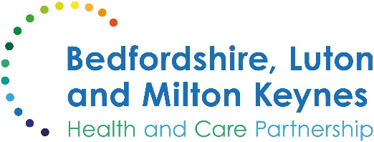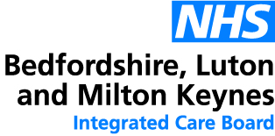

MEDIA RELEASE

31 December 2024

Kickstart your healthier lifestyle in 2025 with NHS support

A senior doctor has reminded local residents that the NHS is on hand to support those who aspire to a healthier lifestyle in 2025.

With the New Year just hours away, many people are making resolutions to improve their health and wellbeing, especially if they have perhaps overindulged a little during the holiday festivities.

Dr Ian Reckless, chief medical officer at Bedfordshire, Luton and Milton Keynes Integrated Care Board, said:

"As we prepare to ring in the New Year, many of us will find ourselves reflecting on our health and wellbeing, especially if you’ve overdone it in the run-up to Christmas. It's no surprise that some of the most common New Year resolutions revolve around health. Many people will want to quit smoking, lose weight, eat better, take regular exercise, get better quality sleep, cut down on alcohol, or take steps to improve their mental health.

“Making these changes can significantly enhance our quality of life, and the NHS provides a wide range of resources and support to help you achieve these health-related goals.

“Whether it's through our helpful apps, expert advice, or personalised programmes, we're here to guide you every step of the way. Let's make 2025 a year of positive change, better health, and renewed vitality together. The NHS is here to help you every step of the way.”

The NHS offers a range of advice sources and programmes for those looking to improve their wellbeing as well as several apps that provide daily encouragement and support for those looking to stop smoking or lose weight.

Additionally, individuals aged 40 to 74 are entitled to a free NHS Health Check every five years. This check-up, which takes just 20 to 30 minutes, involves a trained professional assessing your personalised risk for various health conditions.

For more information on how the NHS can support your health goals in 2025, visit the NHS website or contact your GP.

ENDS

NOTES TO EDITORS

About the Bedfordshire, Luton and Milton Keynes Integrated Care Board
The Bedfordshire, Luton and Milton Keynes Integrated Care Board is responsible for planning the delivery of health care for a population of one million people across four diverse local authority areas – Bedford Borough, Central Bedfordshire, Luton and Milton Keynes.

Our aim is simple. We want everyone who lives in our city, towns, villages and communities to live a longer, healthier life. Our strategic priorities are set out below.

Bedfordshire, Luton and Milton Keynes support two million jobs locally and we are one of the fastest growing economies in England, contributing £110bn to the UK economy.

We represent a diverse population, with 47% of residents in Luton coming from an ethnic minority background and while there is affluence in the more rural communities of Central Bedfordshire, some of our wards are amongst the most deprived in the country.

