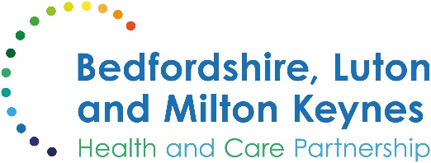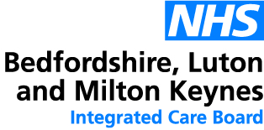

MEDIA RELEASE

01 November 2024

Thousands receive winter vaccinations as NHS campaign gets off to a brisk start

More than 284,000 vaccinations have already been given in Bedfordshire, Luton and Milton Keynes this winter amid an NHS drive to protect against the flu and COVID-19 viruses, new figures show.

Anyone who is eligible can now make an appointment and can book in via the NHS website, the NHS App, or by calling 119 for free. You can also search online for local pharmacies or walk-in sites offering the vaccinations.

A senior local doctor has urged anyone who has not yet come forward to make plans to get their vaccinations in plenty of time for the winter season, reminding eligible patients that thousands of slots are now available for booking at venues in the local area.

Dr Ian Reckless, chief medical officer at Bedfordshire, Luton and Milton Keynes Integrated Care Board, said:

“Having your COVID-19 and flu vaccinations is the best way to protect yourself and those around you from a nasty infection this winter. Both vaccines have a good safety and effectiveness record, and local NHS workers have already protected thousands of people so far this year.

“Across England, millions of people have already been invited to come forward. If you are eligible to receive one or both of the vaccinations then I would urge you to make plans now. You may not realise that you are more vulnerable, but if you are invited for a flu, RSV or COVID-19 jab then it is because you are at greater risk. You don’t need to wait to receive your invitation before booking your slot.

“Figures released recently by the UK Health Security Agency showed that over the past two winters there have been at least 18,000 deaths associated with flu and over 19,500 deaths linked to COVID-19. The threat from these serious viruses remains serious, and as these vaccinations generally take around two weeks to start working, the sooner you come forward and receive yours, the sooner you will be protected.”

Most eligible adults will receive both vaccines at a GP practice or a local pharmacy. If you are pregnant, you may also be able to get the flu and COVID-19 vaccines through your local maternity service. You are eligible at any stage of your pregnancy to help protect you and your baby.

The flu vaccine is also offered to most children. Those in Reception to Year 11 will usually receive a visit from an NHS vaccination team at their school. If your child was aged 2 or 3 years on 31 August 2024, or aged over 6 months to 2 years and in a clinical risk group, you should contact your GP surgery to find out how to get a vaccination. The children’s flu vaccine is usually given as a quick, painless spray up the nose.

You are eligible for a flu vaccination if you:
- are aged 65 years and over (or will turn 65 by 31 March 2025);
- are aged 18 to 64 years and in a clinical risk group;
- live in a long-stay residential care home;
- receive carer’s allowance, or are the main carer of an elderly or disabled person;
- are pregnant;
- are a close contact of someone who is immunocompromised;
- are a frontline worker in social care who isn’t covered by an occupational health service run by your employer.

You are eligible for an autumn COVID booster if you:
- live in a care home for older adults;
- are aged 65 years and over (or will turn 65 by 31 March 2025);
- are aged 6 months to 64 years and in a clinical risk group;
- are pregnant;
- are a frontline health or social care worker, or work in a care home for older adults.

The respiratory syncytial virus (RSV) vaccine is also available if you are aged 75 to 79 or if you are pregnant (28 weeks or more) to protect you and your child. RSV is a common cause of coughs or colds, which can lead to complications including serious lung and chest infections. Evidence suggests this new vaccine could prevent thousands of A&E attendances, hospital admissions, and serious cases this winter alone.

ENDS

NOTES TO EDITORS

Image supplied
[insert image here]

Image description
Dr Ian Reckless (see designation and quote in the main body) receives his flu vaccination.

About the Bedfordshire, Luton and Milton Keynes Integrated Care Board
The Bedfordshire, Luton and Milton Keynes Integrated Care Board is responsible for planning the delivery of health care for a population of one million people across four diverse local authority areas – Bedford Borough, Central Bedfordshire, Luton and Milton Keynes.

Our aim is simple. We want everyone who lives in our city, towns, villages and communities to live a longer, healthier life. Our strategic priorities are set out below.

Bedfordshire, Luton and Milton Keynes support two million jobs locally and we are one of the fastest growing economies in England, contributing £110bn to the UK economy.

We represent a diverse population, with 47% of residents in Luton coming from an ethnic minority background and while there is affluence in the more rural communities of Central Bedfordshire, some of our wards are amongst the most deprived in the country.

