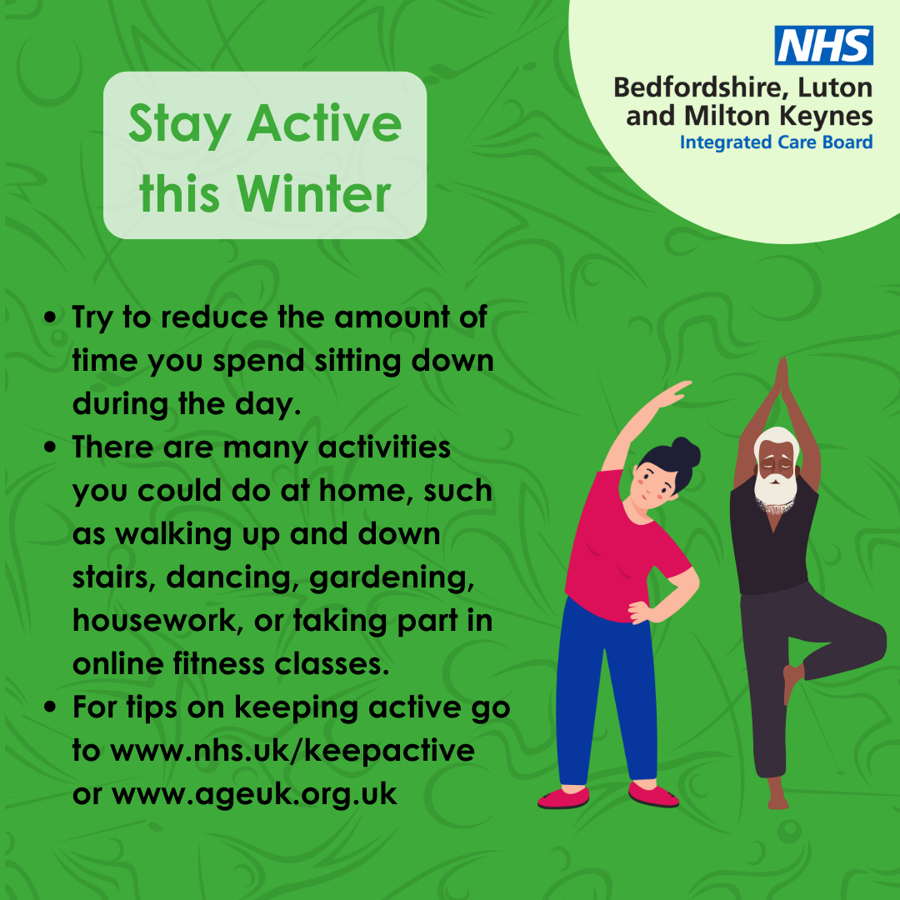

Stay Active This Winter! 🌟
As the days get shorter and colder, it’s easy to let exercise slip. But staying active is crucial for both your physical and mental health, especially during winter! ❄️

Let’s make this winter our healthiest yet!

