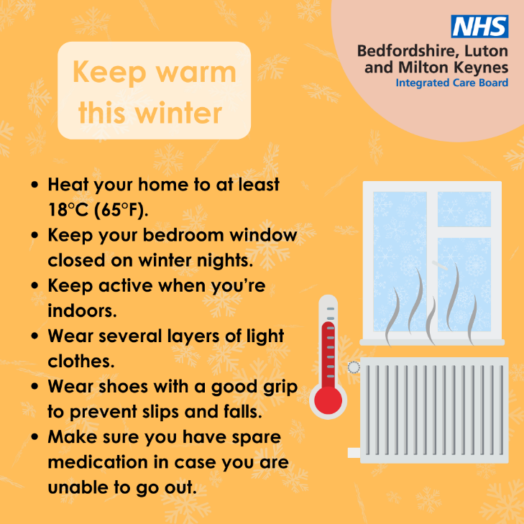

Stay Warm This Winter with Age UK! 🌨️
Winter can be tough, but Age UK has got you covered with essential tips to keep you warm and well. From managing your energy bills to getting your flu and covid jab, there’s plenty you can do to stay healthy.
For more detailed advice, visit Age UK’s winter health guide: Age UK Winter Health Guide 🌟

