“Death is just as important as life”.  Tanya Waite describes how she uses her Whzan Blue Box to give effective end of life care at Arden House, Bedford. | 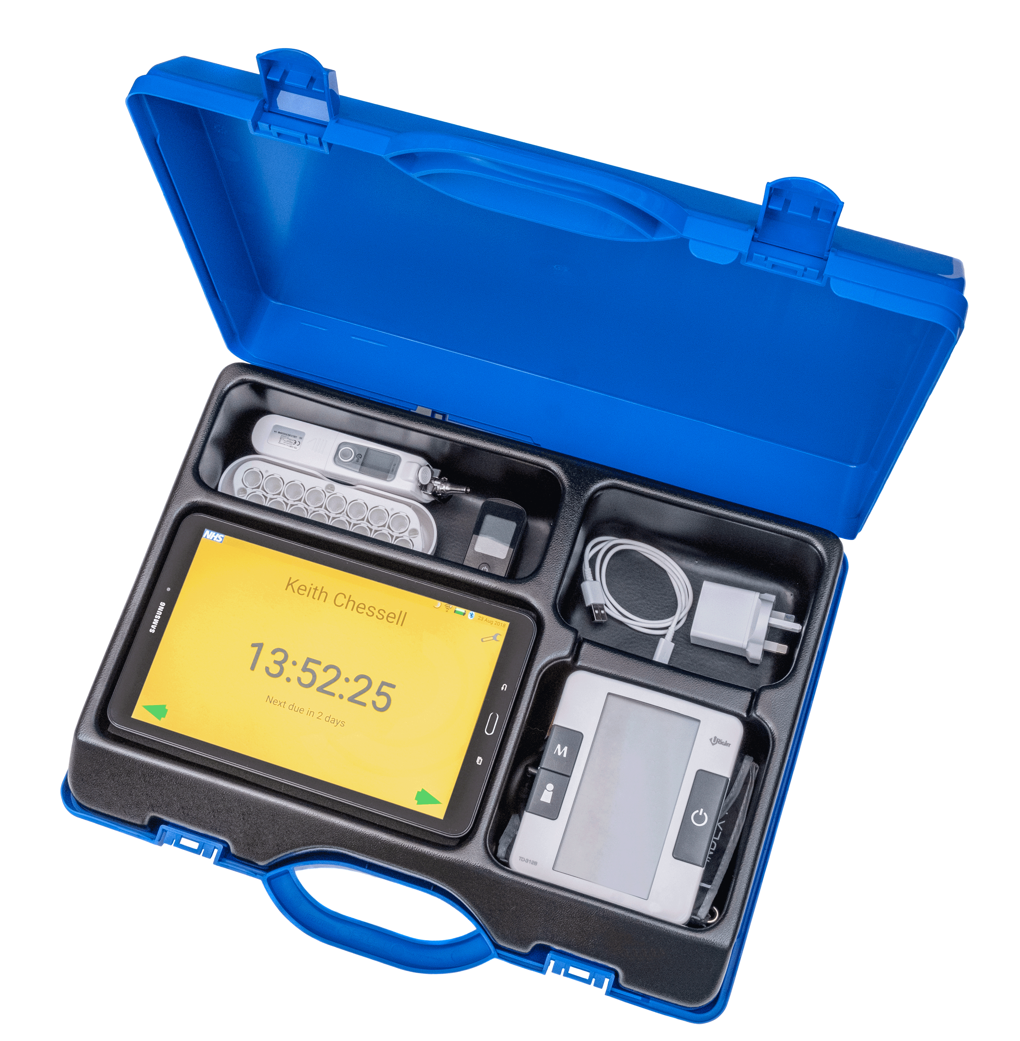

The painful personal experience of not being present at her own mother’s passing ignited Tanya Waite’s passion to ensure that, when the time came, residents in her care would receive unsurpassed end of life care.

Arden House – a residential care home of 24 beds in Bedford – first began using a Whzan kit in October 2018. As the home manager, Tanya Waite’s initial use of the kit was limited to capturing NEWS2 scores – the method used to check if someone who is already ill is becoming worse. As she became more familiar with the equipment, she began to see other possibilities to enhance care for her residents. One of her most profound insights has been that the pulse oximeter supplied with the Whzan kit provides a powerful tool to help indicate the onset of end of life.

“When someone dies in hospital, the nurses and doctors can keep a certain professional distance. When someone dies in a care home, that person will be surrounded by people who they know and trust intimately. As carers, our obligation to do everything in our power to support the resident and their loved ones is something we feel very strongly.”

The pulse oximeter allows Tanya to detect significant variations in heart rate and concentration of oxygen in the blood. These observations, coupled with her detailed knowledge of each resident’s health and wellbeing, enable Tanya to provide meticulous end of life care. She has been able to ensure that relatives and loved ones are at the resident’s bedside when they otherwise might have been absent. One
resident, who was without family or friends, was able to have his wish respected of not being alone at the time of his passing.

Tanya is passionate and uninhibited about death. “It’s a reality that most people find difficult to talk or even think about but, in a care home, it’s an issue we have to plan for and embrace.”

The many five star reviews that Arden House receives for the end of life care given to residents (see www.carehome.co.uk) are testament to Tanya’s conviction.

