The Whzan Blue Box "speaks for residents who can't talk".  Sylvester Mulenga, Senior Carer at Oasis House Bedford, talks about how this telehealth equipment helps him get the right care for his residents. | 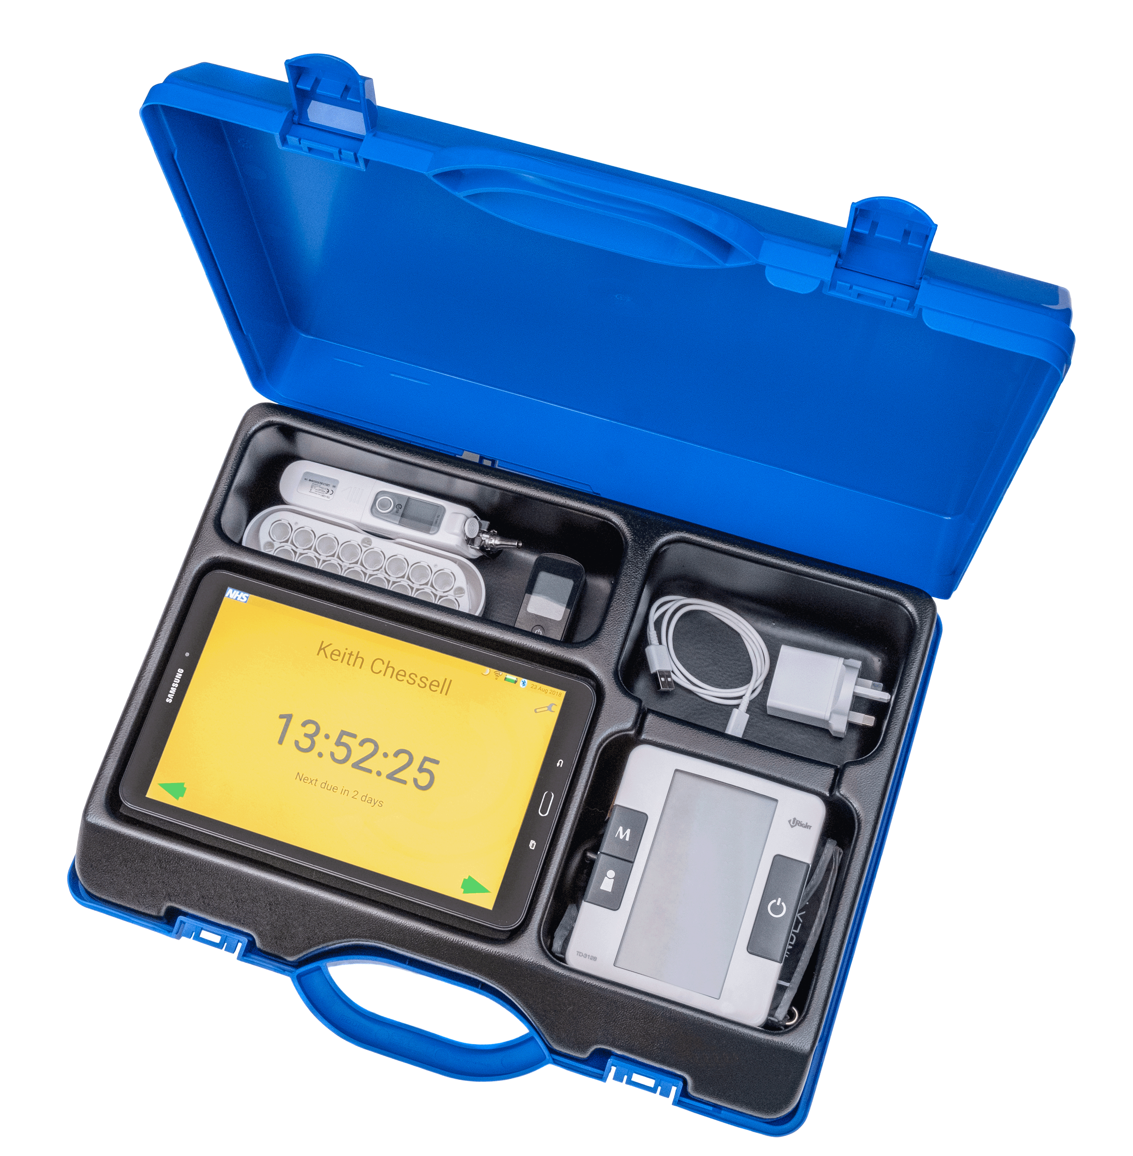

Oasis House is a 30-bed residential care home close to Bedford town centre. The care team at the home first started using the Whzan Blue Box in May 2020 and remain enthusiastic advocates for the all-in-one telehealth kit.

“Before we had this equipment we often had to wait until a resident got really sick before we could get help,” said Sylvester. “Now we can act more immediately because we can get observations – like blood pressure and oxygen saturation – and give these to the GP. This gives us the help we need for our residents much more quickly.”

Sylvester says this is particularly important in helping him and his team care for residents who either can’t speak or can’t explain how they’re feeling. As he puts it, “The Whzan Blue Box speaks for residents who can't talk”.

Carers at Oasis House don’t just use Whzan for emergencies. The equipment is used to routinely work out each resident’s “NEWS2” (National Early Warning Score version 2). This is a simple but powerful way of expressing six different clinical observations as a single number between 0 and 20. The higher the number, the more unwell the resident is likely to be and the more urgent the need for referral to a GP, paramedic or other healthcare professional. Knowing the normal NEWS2 score for a resident helps to support Sylvester when he has a concern.

Having used the equipment for more than two years, Sylvester described it as “a really useful tool for any care home to have”.

