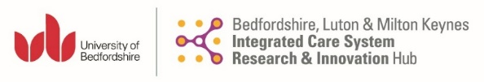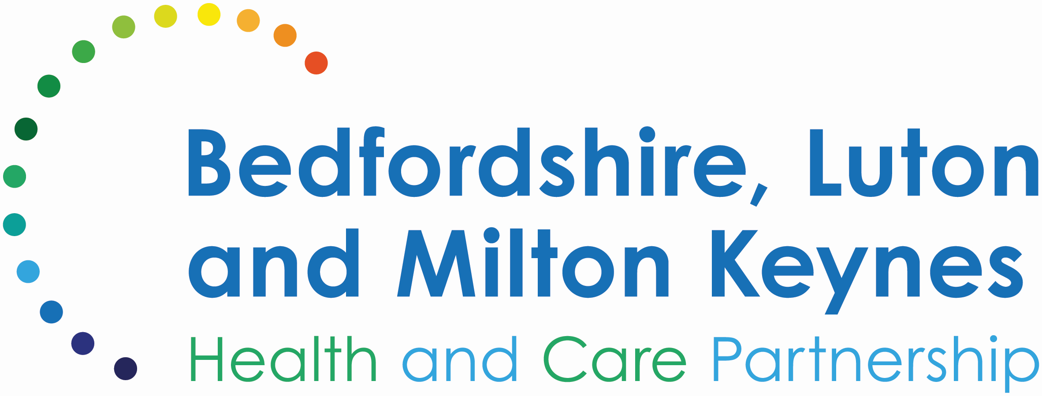
RESEARCH AND INNOVATION FUNDING AWARD (PUMP-PRIMING)

The Faculty of Health and Social Sciences in the University of Bedfordshire was awarded a £3 million grant by NHS England to develop and host the BLMK Integrated Care Research and Innovation Hub (ICS R&I Hub). The Faculty of Health and Social Sciences in the University of Bedfordshire aims to work closely with the BLMK Integrated Care Board (ICB) and represented entities to facilitate Research and Innovation in BLMK and to practically support integrated care initiatives with making tangible step changes where they are needed the most: a) ascertain user needs; b) support innovation; c) address inequalities; d) build capacity for research and innovation.
The BLMK Health and Social Care economy is a vibrant research and innovation area where ideas are profuse. The BLMK ICS R&I Hub wishes to support service providers with developing their plans for research and innovation by providing ‘seed funding’ for up to three applications.

ELIGIBILITY

The University of Bedfordshire (UoB) invites applications for a research and innovation award from clinical and non-clinical staff working in a health, social care or voluntary organisations in Bedfordshire, Luton and Milton Keynes Integrated Care System (BLMK ICS). The aim of this funding is to provide short-term “pump-priming” funding to novel research and/or innovation projects.
All applications must include at least one UOB researcher (named applicant). The lead applicant must have at least 24 months of time remaining in their current role from the start of the award.

SCOPE

The total funding for this call is £45,000. The UoB will fund up to three applications with a total contribution of £15,000 per project (£3,000 to be allocated to cover the UoB staff time). The UoB expect the R&I Funding Award to last for 1 year. However, will consider shorter or longer awards on a case-by-case basis (up to 18 months). It is expected that applicants access other sources of funding to complement this award. Funds in this scheme are provided for time to spend on research, evaluation of innovation, travel, and other collaborative activities, such as workshops or exchanges. Costs will not include overheads or items of equipment.

ASSESSMENT CRITERIA

Applications will be assessed internally by a scrutiny panel consisting of UoB, ICS nominated members of staff and a community representative. The procedure will be overseen by the Director of the BLMK ICS R&I Hub who will report to the Hub’s Steering Committee.

Proposals will be assessed against the following criteria:
- Links to ICS strategic priorities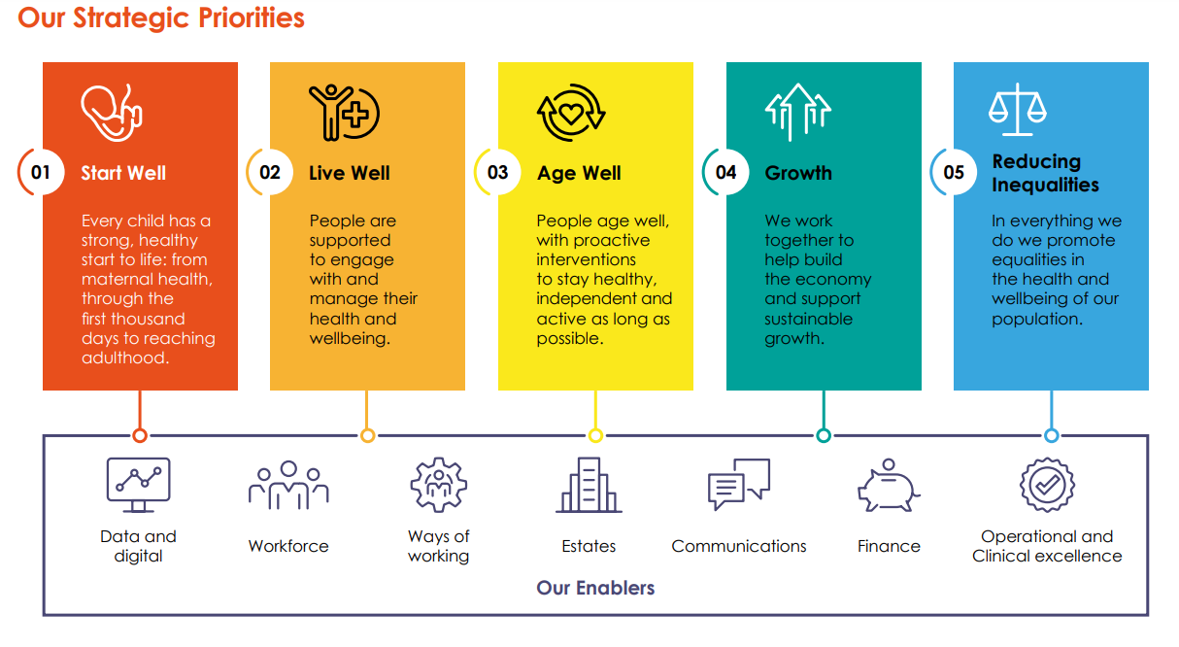

- The future joint research and/or innovation likely to accrue from this collaboration.
- Proven expertise of the partners in research or innovation areas.

Please make sure the application is approved by a senior line manager.

APPLICATION

Applications open on Thursday 1st February 2024.

Deadline to submit this application is Thursday 14th March 2024 17:00 and should be sent to BLMK ICS R&I Hub Project administrator: Dany.Arnaud@beds.ac.uk.

Applicants will be informed of the outcome in May 2024

Completed forms should all be sent over as pdf copy and must not exceed the word count indicated.

Support for applicants who are not successful:
- Applicants who are not successful for this funding award will have the opportunity to discuss their research or innovation project with a panel. The panel will have representatives from health, local authority, innovation, research and the local community. Advice and guidance will be provided on how to progress their idea and access a range of local and regional support.

APPLICATION FORM

Applicant(s) Name:

Name and email address of senior manager supporting application
Date of application:
Job role & organisation in BLMK ICS:
Contact Address:
Contact Number:

Email address:

Study/project Lead ICS:

Study/project Lead UoB:

Support can be provided with identifying a UoB academic to support the bid. please write to: yannis.pappas@beds.ac.uk

Project Title:

Proposed Project Start and End Date:

ICS Priorities addressed
Research or innovation proposal (500 – 750 words):

Problem statement:

Aims/Objectives:

Methods:

State how requested funding will be used

Expected impact of proposed work

Does the expertise of the partners for your research and innovation contribute to this award?

If an innovation project is proposed, provide a plan for evaluation (250 words):
What are your plans to attract funding for further research?

Or

What are your plans to make an innovation sustainable?
FOR OFFICE USE ONLY  Approval by R & I awards scrutiny panel | Date-  Members-

Please email application form to: Dany.Arnaud@beds.ac.uk

Closing date: Thursday 14th March 2024 17:00

